Clinical Advisory Service Newsletter

  - Autumn 2026
  - A photo of the Enable NZ Clinical Advisory Service team in November 2025.

Kia ora
Welcome to our first newsletter for 2026. In this edition the clinical focus is on beds, mattresses, and Trendelenburg use; and we have included several updates and tips that we hope will support you in your day-to-day work.
We also farewell Judith Graham, a highly respected Clinical Advisor after 16 years with Enable NZ.
Please take a minute to complete our newsletter feedback survey to tell us what you value most. We really appreciate your input!
Joanne Taylor-Cross
Clinical Educator, Enable New Zealand

Contents

Updates 3
Vicair products 3
Retirement of Judith Graham 3
Professional development opportunity: join our EMS Evaluation Panels 3
ACC non-list equipment ordering 4
EMS equipment list is now online 4
Tips and Advice 5
Reminder about EMS low-cost equipment 5
EMS service requests: we can’t process them without the Priority Form 5
Housing assessors - are you aware of asbestos regulations and your role in discussing these with clients? 6
Articles and Education 8
‘Intro to MRES’ webinar now available 8
Electric Bed Functions: Trendelenburg 8
Prescribing Beds and/or Mattresses: a full assessment and compatibility are essential 12
Closing words 16

Updates

Vicair products
  - Equipment update
Allied Medical Limited is now the supplier of all Vicair products on the Equipment and Modification Service (EMS) Equipment List and ACC equipment List for Enable NZ.
When requesting funding for Vicair list equipment, please ensure that your quote is obtained from Allied Medical Limited. Quotes from other suppliers cannot be processed and will need to be replaced, which may cause delays.
Non-list cushions or other non-list products: These can be requested from any supplier who is willing to provide them. There are no supplier restrictions for non-list items.

Retirement of Judith Graham
After nearly 16 years with Enable NZ’s Clinical Advisory team, Judith Graham (Physiotherapist) has retired.
During her time with Enable NZ, Judith has generously shared her extensive clinical expertise with assessors and colleagues, providing valued insight, guidance, and support. Her work has spanned a period of significant change across the New Zealand health system, and she has both witnessed and contributed to many operational developments along the way.
We sincerely thank Judith for her many years of skill, collaboration, and the thoughtful conversations she has shared. We wish her every happiness in her retirement and all the very best for the future.

Professional development opportunity: join our EMS Evaluation Panels
We are inviting experienced Level 2 clinicians to a volunteer role: Join one of our expert panels for Wheeled Mobility and Postural Management (WMPM) or Communication Assistive Technology (CAT).
As a panel member, you will review case studies and support applications from clinicians working towards WMPM Level 2 or CAT Level 2. This is a good chance to share your skills, help set our standards, and support the next group of clinicians.
If you are already a WMPM Level 2 or CAT Level 2 clinician and want to help, we would love you to join.
Keep an eye on your inbox for emails about how to apply.

ACC non-list equipment ordering
ACC and Enable NZ are maintaining a focus on higher cost non-list equipment requests as part of ongoing work to improve service delivery and sustainability.
It’s important that requests include:
- clear clinical rationale
- supporting information
While the submission process is the same, ACC or Enable NZ may contact you more often if this key information is missing.
Read the full message from ACC.

EMS equipment list is now online
The Equipment and Modification Service (EMS) equipment list is now available as a searchable online catalogue. We hope that you have been able to try out this new tool.
Benefits of this online list:
- Access it on any smartphone, tablet or computer.
- Search and filter the catalogue to quickly find items.
- Browse by different sections.
- Or you can download the full list as a PDF.
View the online EMS equipment list on our website.
If you have any questions or feedback, we’d love to hear from you at enable.co.nz/contact. We’re committed to continually improving your experience with this resource.

Tips and Advice

Reminder about EMS low-cost equipment
A reminder to all EMS assessors regarding the requirement for funding of low-cost items.
These items can be accessed via the Band 1 automated process, so assessors need to ensure they have the supporting documents for eligibility on file and available for auditing if requested.
Section 6.3 of the Disability Support Services (DSS) EMS equipment manual 2014 explains low-cost equipment in this way:
Low-cost equipment is generally valued by the EMS Provider as $50 (incl. GST) or less. Low-cost equipment items cannot be packaged together to total more than $50 (incl. GST), for example, knife, fork and spoon.
Low-cost equipment items are generally not funded but will be considered in the following situations (subject to the usual eligibility and access criteria being met):
- The person is under 65 years of age and living in residential care and the items are essential to support their personal safety, or
- The person is unable to pay due to hardship and is receiving either a special benefit or temporary additional support from Work and Income (written confirmation from Work and Income is required), or
- The person is under 16 years old.
The EMS Assessor should provide the person with information on where they can purchase low-cost items (e.g., walking sticks, long handled hairbrushes, reachers or special cutlery).

EMS service requests: we can’t process them without the Priority Form
A friendly reminder that DSS requires a completed ‘EMS Priority One rating form’ (sometimes called a ‘Priority Tool’ or ‘Priority Form’) to support your funding requests. This form, developed by DSS, helps ensure that all applications meet the criteria for funding consideration.
It is a separate form that must be completed and submitted with every service request for:
- Band 2 and 3 Equipment (including wheelchair and seating)
- Basic and complex housing modifications
- Vehicle modification applications
Service requests cannot be processed without the completed Priority Form. It is not required to be provided with Request for Advice applications.
Important things to remember:
- Priority 1 (P1) does not mean urgent funding is approved - only that the person is eligible for funding.
- Priority 2 (P2) funding is released only when the Ministry decides it can be processed; this is not a decision that can be made by Enable NZ.
For more information, visit the ‘Prioritisation Guideline and Q&As’ page on the DSS website.

Housing assessors - are you aware of asbestos regulations and your role in discussing these with clients?

Asbestos Regulation 2016 – key points for Housing Modification assessors
Under the Health and Safety at Work (Asbestos) Regulations 2016, an Asbestos Refurbishment Survey is required for properties built before 2000 where modification work is planned.

Current process
- The asbestos survey is typically completed after working drawings and tenders are prepared.
- Survey results are sent to Enable NZ.
- Enable NZ obtains quotes from qualified contractors for asbestos removal.
- Removal and disposal costs are the responsibility of the property owner.

Recommended improvement
Enable NZ recommends completing asbestos testing as soon as the designer accepts the referral for all pre 2000 homes.
This approach:
- Allows early notification to clients if asbestos is present.
- Identifies potential removal costs before design work begins.
- Avoids unnecessary design costs if a referral is withdrawn.
- Reduces delays if modification work proceeds.

What do you need to do as a Housing Modification assessor?
- Inform clients with pre 2000 homes that asbestos testing may be required before any modification work.
- If asbestos is identified:
  - Inform the property owner that they are required to pay for removal.
  - Inform your client that no modification work can proceed until asbestos is safely removed.
- The designer arranges testing, and the testing cost is included in the design fee.

ACC housing requests
These are assessed case by case, and asbestos costs may be covered as part of the modification.

Articles and Education

‘Intro to MRES’ webinar now available
We recently hosted a live webinar for ACC assessors working with the Managed Rehabilitation Equipment Services (MRES).
In this webinar we:
- Introduced the MRES Clinical Advisory Service and explored how our team can support you with equipment selection and ordering.
- Highlighted a range of helpful resources available on the Enable NZ website.
- Discussed everything you need to know about placing MRES orders.
This webinar was an ideal introduction for new assessors or anyone new to using the MRES app.
If you missed it or would like to watch it again, the full webinar recording and PowerPoint slides are now available. Visit the ‘Assessor education webinars’ page on our website to view and download.

Electric Bed Functions: Trendelenburg
Written by Deborah Gamble and Jemmah Lousley, Clinical Service Advisors, Enable NZ

Introduction
Correct positioning is vital in providing comfort while preventing discomfort associated with prolonged immobility. It aids in maintaining alignment, reducing pain and strain on muscles and joints. Effective positioning can prevent critical complications such as pressure injuries and pulmonary issues (Breeze Hospice Services, 2025).
Available electric profiling beds in Aotearoa come with many of the following features, including Trendelenburg and reverse Trendelenburg. It is important as a prescriber of this equipment, to know what these functions can be utilised for. Funding under DSS and ACC has a strong focus on function and essential disability need and injury related need respectively, and while there may be flow on benefits for medical needs, beds cannot be funded solely for this. In this brief article, we will provide an overview of Trendelenburg functions available and how these may best meet your clients' needs within the home.

Trendelenburg
The Trendelenburg position — named after surgeon Friedrich Trendelenburg, was first developed to improve access to pelvic organs during surgery. It was once used to help manage low blood pressure, but research has shown that it offers little benefit, and can potentially cause harm in patients, with shock (Cleveland Clinic, 2025). Today, its use has shifted to more specialised, short duration clinical applications.
Because the need for Trendelenburg is prescribed by the medical specialist, justification for its use needs to be clear and well documented in applications for funding.
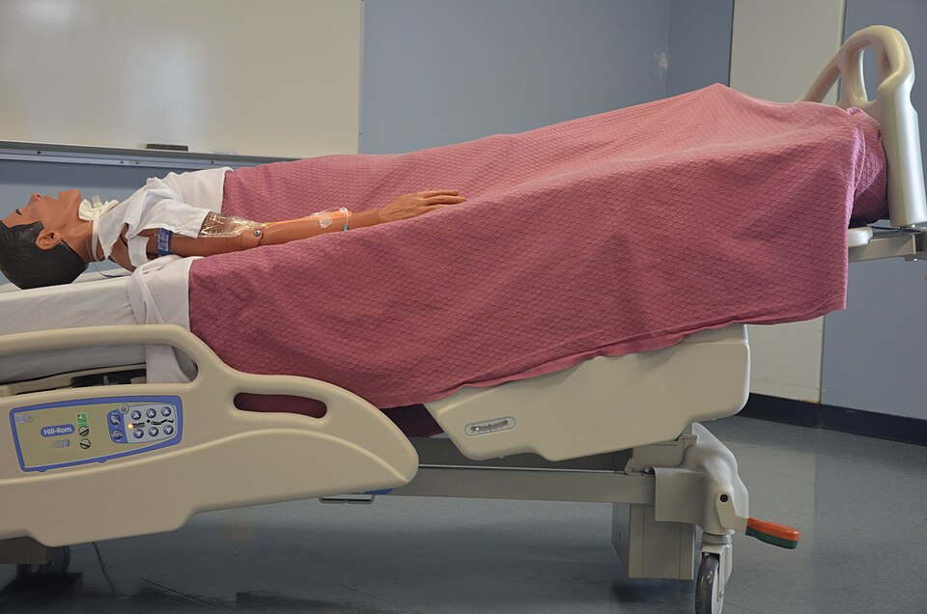
Figure 1. Note. From [Medical Mannequin Placed in the Trendelenburg Position], by Doyle & McCutcheon, [2015]. Creative Commons (2022)
Trendelenburg’s position involves lowering the head of the bed and raising the foot of the bed. It can be used if medically prescribed, for short duration and if the client is continuously monitored. There are many acute medical situations where Trendelenburg may be used, however these are not scenarios that we would frequently see in the community.

Practice note
If Trendelenburg is used in the community, it should be limited to short, specific tasks and only under the guidance of a healthcare provider. Evidence indicates that the Trendelenburg position has limited proven benefit and may be associated with adverse physiological effects, particularly when used for prolonged periods (Ostrow, 1997; Allina Health, n.d.). Clinical guidelines emphasize the importance of individual risk assessment and close monitoring when positioning is used to reduce the risk of harm (Speth, 2023). Measures to prevent accidental prolonged positioning, such as locking the handset, should therefore be considered (Cubro, n.d).
Ripa et al, 2022 note that steep Trendelenburg (25 – 45 degrees) can result in increased intraocular pressure.

Reverse Trendelenburg (Head Up)
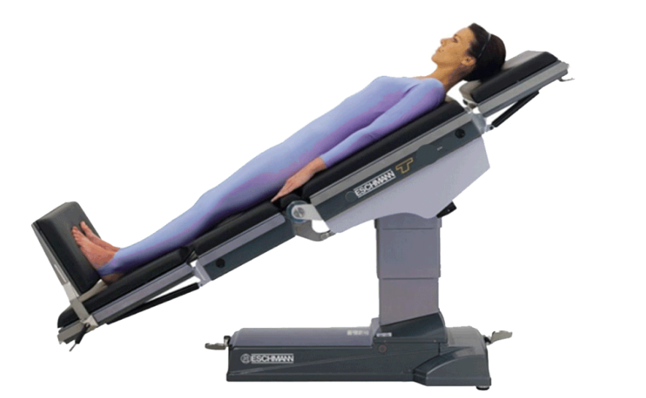
Figure 2 Reverse Trendelenburg (Head Up)
Reverse Trendelenburg is where the patient is positioned in supine, with their head elevated and feet lowered, typically between 15 and 30 degrees. The use of reverse Trendelenburg is described in many journals as it relates to surgical positioning to aid visibility and access, reduce blood flow to the upper body, support respiration and reduce intracranial pressure and intraocular pressure (Mediksurgical, 2025).

Practice note
Clinical guidance highlights that Reverse Trendelenburg is not recommended as a standard long‑term resting or sleeping position and requires close monitoring. Reverse Trendelenburg causes the body to slide downward on the bed, increasing shear and pressure injury risk, particularly to the heels and sacrum (Nurse.com, 2025).
There may be increased discomfort in this position, reverse Trendelenburg can lower blood pressure resulting in blood pooling in the lower body. (Ramos et al, 2025).
Avoid Trendelenburg except for brief, goal directed specific tasks such as boosting/repositioning an individual up or down the bed in conjunction with slide sheet use.

References
Journal articles
- Ostrow, C. L. (1997). Use of the Trendelenburg position by critical care nurses. American Journal of Critical Care, 6, 172–176.https://doi.org/10.4037/ajcc1997.6.3.172
- Ramos, M. B., Britz, J. P. E., Rech, M. M., do Nascimento, V. P. A., Borges, P., Batista, S., & Figueiredo, E. G. (2025). The effects of reverse trendelenburg position during intracranial neurosurgery on brain hydrodynamics and hemodynamics: a systematic review and meta-analysis. Neurosurgical review, 48(1). https://doi.org/10.1007/s10143-025-03655-2
- Ripa, M., Schipa, C., Kopsacheilis, N., Nomikarios, M., Perrotta, G., De Rosa, C., Aceto, P., Sollazzi, L., De Rosa, P., & Motta, L. (2022). The Impact of Steep Trendelenburg Position on Intraocular Pressure. Journal of Clinical Medicine, 11, 2844. https://doi.org/10.3390/jcm11102844
Web pages / organisational documents
- Allina Health. (n.d.). Use of the Trendelenburg position during hypotensive episodes: An evidence-based practice guideline. Allina Health.
- Breeze Hospice Services. (2025, March 7). The benefits of regular positioning and mobility assistance in bedside care. https://www.breezehospiceservices.com/resources/the-benefits-of-regular-positioning-and-mobility-assistance-in-bedside-care
- Cleveland Clinic. (2025, July 7). Trendelenburg position: What it is, why it’s done & variations. https://my.clevelandclinic.org/health/procedures/trendelenburg-position
- Cubro. (n.d.). Beds rationale support guide (v3). https://www.cubro.co.nz/assets/Uploads/Beds_Rationale-support-guide-_v3.pdf
- Cubro. (n.d.). Bock® Practico ultralow bed [NZ product page]. https://www.cubro.co.nz/healthcare-products/beds/hospital-beds/bock-practico-ultra-low-bed
- Mediksurgical (2025, May 22). Reverse Trendelenburg Position in Surgery. www.mediksurgical.com/patient-positions/reverse-trendelenburg-position-in-surgery.html
- Nurse.com. (2025, May 15). A guide to reverse Trendelenburg position (Reviewed by J. Oh, BSN, RN). https://www.nurse.com/nursing-resources/definitions/guide-to-reverse-trendelenburg-position/
- Speth, J. (2023). Guideline for positioning the patient. In AORN guidelines for perioperative practice. Association of perioperative Registered Nurses.
Images
- Figure 1: Medical Mannequin Placed in the Trendelenburg Position. Note. Doyle & McCutcheon, [2015]. Creative Commons. https://opentextbc.ca/clinicalskills/chapter/3-4-positioning-a-patient-in-bed/.
- Figure 2: Reverse Trendelenburg (Head Up) Note. From [Wikimedia Commons], by Anonymous 2013.

Prescribing Beds and/or Mattresses: a full assessment and compatibility are essential
Written by Dheshini Naidoo, Clinical Service Advisor, Enable NZ.
A comprehensive assessment is essential when prescribing a profiling bed and/or mattress.
The right bed and mattress combination has the following benefits:
- Lower pressure injury risk
- Safer transfers
- Improves bed mobility
- Enhances client independence
- Reduces carer strain

New Zealand Clinical Evidence Supporting Best Practice
- The 2025 International Guideline states that “full body support surfaces are specialized mattresses… designed to redistribute pressure, reduce friction and shear, and aid microclimate management,” achieved through “envelopment and immersion capabilities.” (InterPIP/NPIAP/EPUAP/PPPIA, 2025)
- The ACC SCI Consensus Statement reports that “people with a SCI are more susceptible to developing pressure injuries… and due to the nature of their injury they require expert support and treatment,” and that prevention is “critical to avoid a long lasting negative impact on… health, wellbeing, and quality of life.” lasting negative impact on… health, wellbeing, and quality of life lasting negative impact on… health, wellbeing, and quality of life (Accident Compensation Corporation, 2022)
- NZWCS notes that “thousands of New Zealanders get a pressure injury each year… most are preventable,” with serious consequences including “long periods of bed rest… and in the most severe cases, death.” (New Zealand Wound Care Society, n.d.)
- ACC confirms that pressure injuries “delay a return to everyday life,” and “prolong hospital stays,” and that they “can develop quickly in people who are sitting or lying for long periods.” (Accident Compensation Corporation, n.d.)

Key Bed Features to Consider
When prescribing a profiling bed, consider how each feature contributes to mobility, safety, and skin protection. These features can directly influence functional independence and carer wellbeing.
- Height adjustable
- 4 section bed (elevating head and leg raise/knee break)
- Ultra-low
- Trendelenburg / Reverse Trendelenburg
- Mattress compensation
- Under bed clearance
- Accessories required

Understanding the different types of Mattresses
As part of delivering accurate, clinically reasoned recommendations, it is helpful to have an overview of the Support Surface Standards Initiative (S3I) (National Pressure Injury Advisory Panel, n.d.). The S3I is a subcommittee of the National Pressure Injury Advisory Panel (NPIAP) Standards Committee. It coordinates the development of uniform terminology and education for support surfaces. Visit the S3I website for more information.
Key Mattress Features to Consider:

- Types of support surface: Reactive or Active
- Mattress components/materials and design features: e.g. foam, hybrid, static air, air alternating, multi zoned surfaces, powered, non-powered.
- Performance Characteristics: envelopment, immersion, microclimate, pressure redistribution.

Clinical Documentation
Clear clinical documentation ensures appropriate supply and supports safe decision-making. Include:
- The specific features required (e.g., alternating pressure, knee break, lateral rotation).
- The clinical rationale, linked to mobility, skin and tissue viability, transfer methods, and carer safety.
- Any trial outcomes or client-specific functional considerations.
- The clinical rationale for considering / discounting DSS and ACC List equipment in the first instance.

Assessment Support for Therapists
Enable NZ Clinical Service Advisors previously presented a webinar on “Considerations for bed and mattress solutions” and most recently developed a “Factors to consider when choosing beds and mattresses” handout to support assessors during the assessment process when considering bed and mattress solutions. It includes:
- Evaluating client mobility and transfer needs
- Assessing pressure injury risk
- Identifying appropriate support surface categories
- Ensuring bed and mattress features align with clinical goals

Conclusion: Why Your Assessment Matters
A detailed assessment, supported by the Enable NZ Bed and Mattress Consideration Form and guided by NZ’s national pressure injury frameworks, ensures that clients and carers receive the safest, most appropriate and necessary equipment.

References
- National Pressure Injury Advisory Panel, European Pressure Ulcer Advisory Panel, & Pan Pacific Pressure Injury Alliance. (2025). Support surfaces — International guideline: Full body support surfaces for prevention of pressure injuries (Part 1). In Prevention and treatment of pressure ulcers/injuries: Clinical practice guideline (4th ed.). https://www.internationalguideline.com/surfaces
- Accident Compensation Corporation. (2022). Pressure injury in spinal cord injury: Consensus statement. https://www.acc.co.nz/assets/provider/acc8305-pi-sci-consensus-statement.pdf
- New Zealand Wound Care Society. (n.d.). Pressure injury – public resources. https://nzwcs.org.nz/resources/pressure-injury-resources?view=article&id=163
- Accident Compensation Corporation. (n.d.). Helping prevent pressure injuries. https://www.acc.co.nz/preventing-injury/helping-prevent-pressure-injuries
- National Pressure Injury Advisory Panel. (n.d.). Support Surface Standards Initiative (S3I). https://npiap.com/page/S3I

Closing words
As we close out the first quarter of the year, we hope this newsletter has provided you with some useful information and practical support to help you with your work prescribing rehabilitation equipment and housing modifications.
We remain committed to offering guidance and resources that help achieve consistent, high-quality outcomes for tāngata whaikaha and their whānau. Your insights and feedback continue to be essential in shaping our processes and service improvements. So please let us know if you have any suggestions for future newsletters or other educational opportunities - send an email to joanne.taylor-cross@enable.co.nz.
Thank you for your ongoing collaboration and for the meaningful impact you make across Aotearoa.

Joanne Taylor-Cross
Clinical Educator, Enable New Zealand

