MRES User Access Guide
for ACC staff

  - Using Single Sign-On (SSO) to access
  - the MRES Application

Version history
Release | Status | Date | Author | Description of Release
1.0 |  | 9 February 2026 | Natalie Dalziel, Enable New Zealand

Contents
Version history 2
Purpose of this guide 2
What is changing 2
What is not changing 3
What you need before you start 3
How Single Sign-On (SSO) works for ACC staff 3
How to access MRES 3
Troubleshooting 6
Key points to remember 8

Purpose of this guide
This guide explains how ACC staff will access Enable NZ’s Managed Rehabilitation Equipment Services (MRES) system using Single Sign-On (SSO).
These changes are part of the MRES Multifactor Authentication (MFA)/SSO Project of April 2026.

What is changing
You will no longer use a separate email and password to access MRES. Previously, you logged into MRES by entering a username and password specifically for this system. Now, in most cases, you will be automatically logged in. This is referred to as single sign-on. MRES identifies that you are already logged into your ACC Microsoft account, then automatically permits you to access MRES.

What is not changing
- You will continue to use MFA as you do today when you are working outside of ACC’s network.
- Your MRES role and permissions remain the same
- How you do your day-to-day work in MRES does not change

What you need before you start
To access MRES using SSO, you need:
- An active ACC Microsoft account (this is provisioned when you start work at ACC and is your ACC email address and password that you log into your laptop with)
- Access to MRES approved by your team or manager. If you are an existing MRES user when the SSO change is introduced, you do not need to do anything.
If your manager has not requested MRES access for you, they can do so here: https://enable.co.nz/acc-users
- If your manager has requested access to MRES on your behalf, and the Enable Technology Service Desk has provisioned your access then there is nothing further you need to do; you are ready to use MRES.
- There is no ‘first-time setup’ required for ACC staff. If your access has been provisioned, you can simply click the MRES link

How Single Sign-On (SSO) works for ACC staff
Single Sign-On means:
- You log into your laptop using your ACC account credentials
- You can then access MRES without entering another username or password

How to access MRES
  - Option 1: Accessing MRES from within the office
Step 1: After logging into your laptop with your ACC email address and password, navigate to the MRES login page here: ACC MRES Login
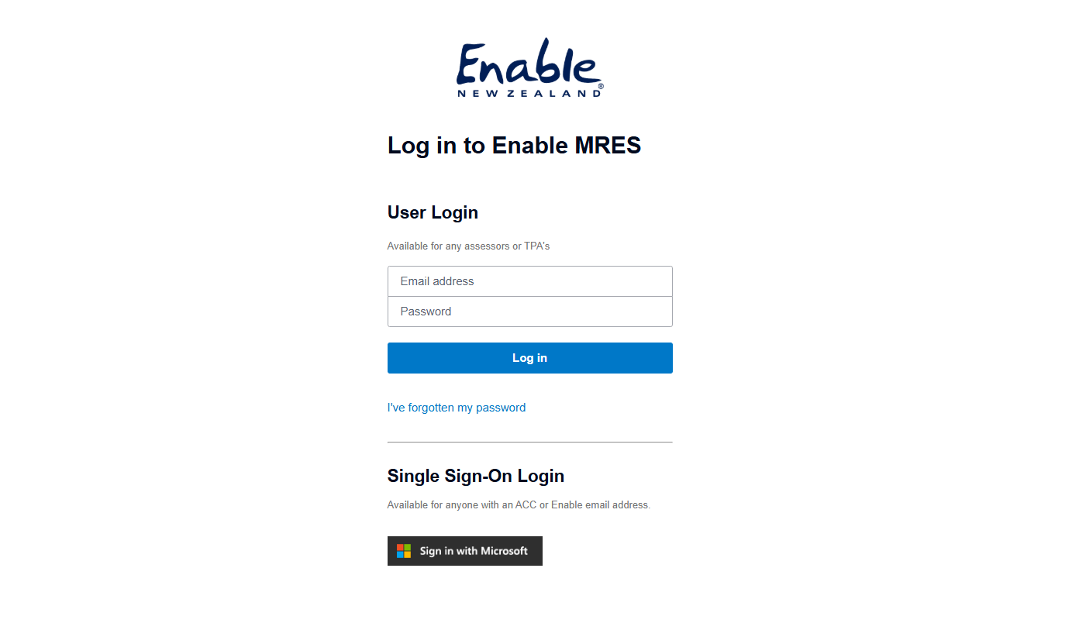

Step 2: If you have been given access to MRES and it is set up correctly, MRES will open automatically
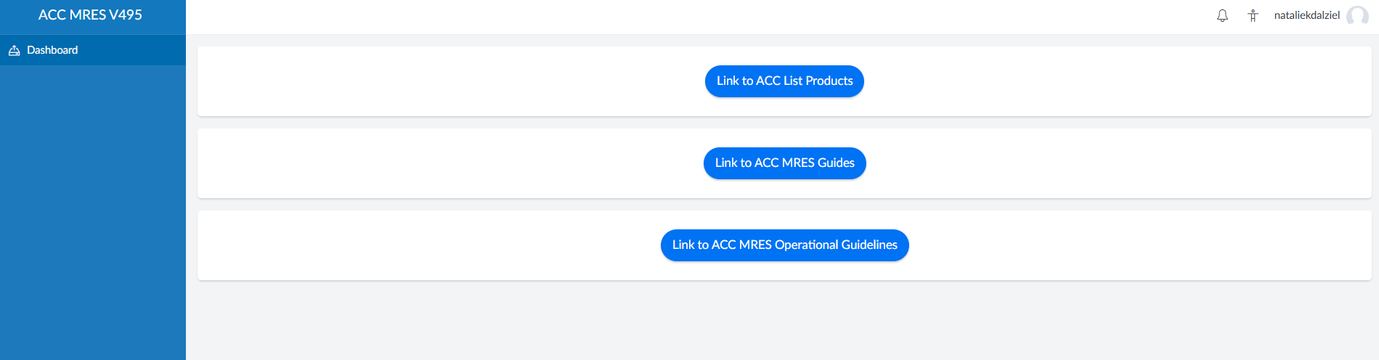

  - Option 2: Accessing MRES from home or outside the ACC network
Step 1: Log into your ACC laptop as you normally would using your ACC email address and password.
Step 2: Complete the MFA steps.
You may be asked to complete MFA when:
- You are logging in to your laptop from home or offsite
- You are using a new or unrecognised device
- Your session has timed out
You may not be prompted for MFA when:
- You are on a trusted ACC device
- You are logged into your laptop and have already signed in to Microsoft services (e.g. Outlook, Teams)
Both behaviours are normal and expected.
Step 3: Navigate to the MRES URL: ACC MRES Login
  - Option 3: I have been logged out of MRES automatically and want to sign back in
This is usually due to session timeout which is a normal security feature of MRES. For security reasons:
- Your MRES session may time out after a period of inactivity
- If this happens, you will be redirected to Microsoft sign-in. Enter your ACC email address and password.
- You may or may not be asked for MFA, depending on your device and location
Simply sign in again and click the MRES link (ACC MRES Login) to continue working.

  - Common scenarios
“I clicked the MRES link and went straight in”
This means SSO worked as expected and you were already authenticated.
“I was asked for MFA even though I logged in earlier today”
This can happen due to security policies or session expiry. This is normal. Just follow the steps to re-authenticate with MFA and then open MRES again by clicking this link: ACC MRES Login
“I was logged out while working”
Your session likely timed out. Sign in to MRES again to continue.
“I was working in the office and then took my laptop to work from home”
When you are working in the office you do not need to complete the MFA process. Now that you have moved outside the ACC network, you will need to log in with MFA, and then you can access MRES again by clicking this link: ACC MRES Login

Troubleshooting
- You are in the office or on the ACC network, but MRES does not sign you in automatically when you click the link. You will most likely see this message:
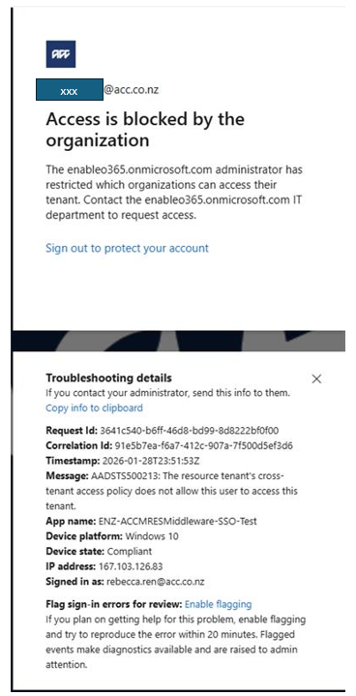

- This is most likely because you have not been set up correctly in Microsoft to access MRES.
- Check you are logged into Microsoft with your ACC account. After logging into your laptop open Teams or Outlook and then try the MRES link again
- Refresh the browser and try again
- If this is your first time logging in to MRES, confirm with your manager that your MRES Access has been provisioned by the Technology team.
- Confirm you are connected to the ACC network.
- If you still cannot Access MRES, contact the Helpdesk or raise a HelpIT ticket for assistance.
- If you are repeatedly asked to log in to MRES
- Close all browser Windows and Microsoft applications such as Outlook, Word, and Teams
- Reopen your browser or Microsoft application and sign in again
- Your password may have expired for Microsoft. Close all internet browser Windows, and Microsoft applications such as Teams and Outlook. Hold down Ctrl, Alt, and Delete on your keyboard at the same time and click “Change a Password”. Reopen MRES.
- You may have lost access to MRES. Contact the Helpdesk to confirm if your MRES Access is still valid.
- You are working from home or outside the ACC network and cannot access MRES
- You are most likely not authenticated with MFA. Close Teams and Outlook, reopen them, and you will be prompted to sign-in again. This will trigger the MFA process. You will be asked for your username and password and the system may ask for a number displayed to you on the Microsoft Authenticator app or via text message on your phone. Once you have completed this process, try to access MRES again.
- You are not automatically signed into MRES, it is asking for a username and password
- If you are in the office, confirm you are connected to the network
- If you are working from home or outside theACC network, make sure you have authenticated with MFA
- Ensure you still have access to MRES. Your access may have expired or been removed.

Key points to remember
- You no longer need a separate MRES username or password you will be signed in automatically when you click the MRES link, provided you have been given Access to MRES and you are on the ACC network.
- If you are working offsite, you will need to sign into your laptop with MFA which requires entering your ACC username and password and then entering a code or validating yourself using a secondary method such as a text message. You can then click the MRES link to Access the system as usual.
- Your MRES role and access remain unchanged

  - For further assistance contact the Enable Technology Helpdesk here: Contact us | Enable New Zealand.

