MRES User Access Guide
for Assessors

  - An updated guide to using
  - the MRES Application

Version history
Release | Status | Date | Author | Description of Release
1.0 |  | 9 February 2026 | Natalie Dalziel, Enable New Zealand

Contents
Version history 2
Purpose of this guide 2
What is changing 2
What is not changing 2
What you need before you start 3
How to access MRES 3
Troubleshooting 6
Key points to remember 7

Purpose of this guide
This guide explains how ACC accessors will access Enable NZ’s Managed Rehabilitation Equipment Services (MRES).
These changes are part of the MRES Multifactor Authentication (MFA)/SSO Project of April 2026.

What is changing
You will continue to enter a username and password to access MRES, however now, if you are a first time user, you will be asked to enter a verification code the first time you login in order to change your password from the temporary one supplied when you are first registered as an MRES user.

What is not changing
- Your MRES role and permissions remain the same
- How you do your day-to-day work in MRES does not change

What you need before you start
To access MRES you will need:
- An active MRES account (this is requested by ACC from Enable NZ when you start work). When your access is provisioned by Enable you will receive a user name and temporary password sent to your email address.
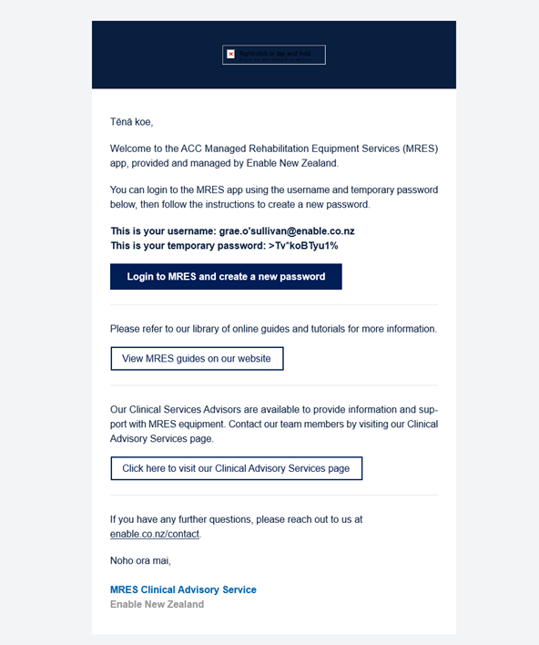
- Access to MRES must be approved by your manager/ACC employer.

How to access MRES
  - Option 1: Accessing MRES as a first time, or existing user
Step 1: After logging into your laptop navigate to the MRES login page here: ACC MRES Login
Do not select “Login with Microsoft” you will receive an error saying NO SSO Access.
Step 2:
If this is your first time logging in:
- Check your emails for your username and temporary password
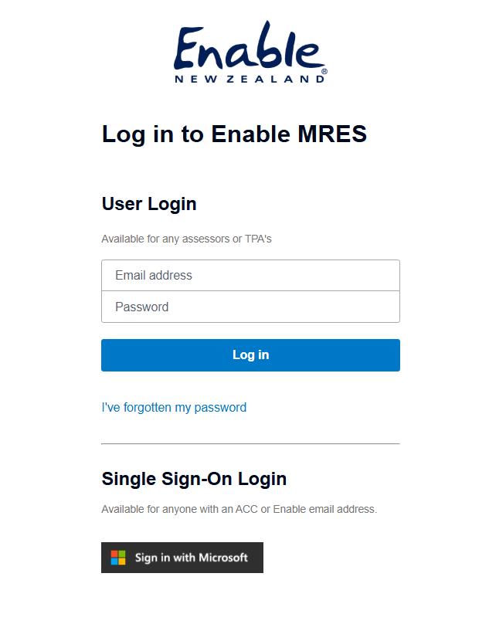
- Log in with the provided credentials
  - If you receive an error saying your password is incorrect confirm you have entered the correct details or the temporary password has expired. If so, click “I’ve forgotten my password” and this will trigger a verification code sent to your email address to allow you to reset your password. Enter the code.
- Set a new password that meets the criteria.
- Log in again with the new credentials.

If you have logged in previously:
- Enter your username and password
  - If you have forgotten your log in details, click “I’ve forgotten my password”. This will trigger a verification code sent to your email address to allow you to reset your password. Enter the code.

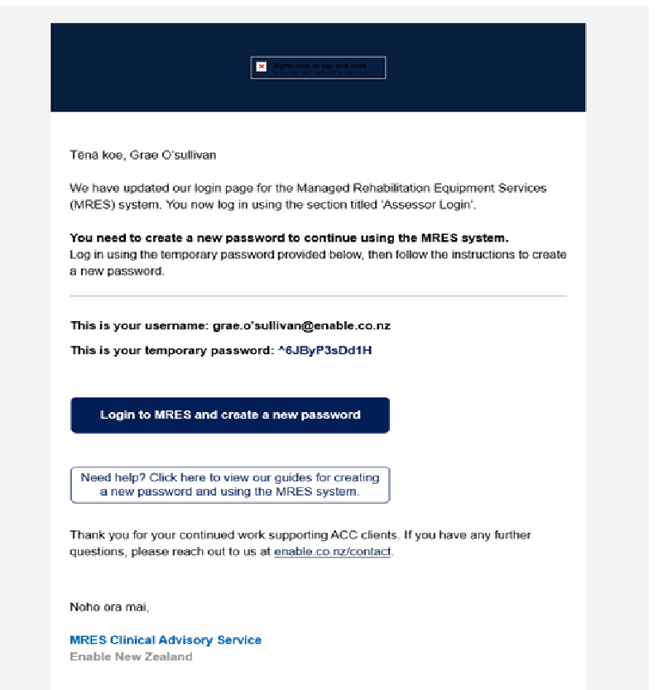
- Set a new password that meets the criteria.
- Log in again with the new credentials.

Step 3: If you are logged in successfully, MRES will open to the Dashboard:
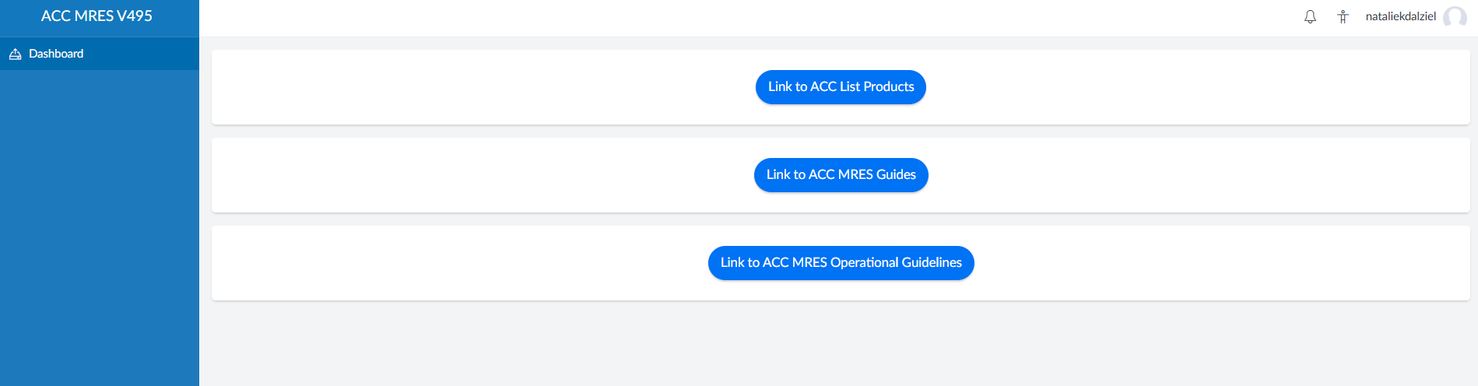

  - Option 2: I have been logged out of MRES automatically and want to sign back in
This is usually due to session timeout which is a normal security feature of MRES. For security reasons:
- Your MRES session may time out after a period of inactivity
- If this happens, you will be redirected to the logon screen to log back in. Simply sign in again and click the MRES link (ACC MRES Login) to continue working.
- You may or may not be asked to complete Multifactor Authentication steps. These are set by ACC so if you have MFA issues, please contact the ACC technical helpdesk.

Troubleshooting
If you experience issues accessing MRES, refer to the guidance below.

I am receiving a “NO SSO Access” error
ACC Assessors must log in using their MRES username and password.
Do not select “Login with Microsoft.”
Return to the login page and enter your MRES credentials.

My temporary password does not work
This may happen if:
- The temporary password has expired
- The password was entered incorrectly
Select “I’ve forgotten my password” to reset it.
A verification code will be sent to your registered email address.

I did not receive the password reset email
- Check your junk/spam folder
- Confirm you entered the correct email address
- Wait a few minutes and refresh your inbox
If you still do not receive the email, contact the Enable Technology Helpdesk.

I receive a message saying my account is locked
Accounts may lock after multiple unsuccessful login attempts.
Wait 15–30 minutes and try again.
If you remain locked out, contact the Enable Technology Helpdesk.

I was logged out while working
This is usually due to session timeout, which is a normal security feature.
Return to the login page and sign in again.

I cannot access MRES
Possible reasons:
- Your access has not yet been provisioned
- Your access has expired
- Your account has been removed
Contact the Enable Technology Helpdesk to confirm your access status.

Key points to remember
- Your MRES role and access remain unchanged with the new login process
- Check your spam/junk folder if you cannot find emails or verification codes sent from Enable NZ when logging into MRES
- The temporary password sent to you when you were first set up as an MRES user may expire. If you get an error when logging in for the first time, click “Forgot my Password”.

  - For further assistance contact the Enable Technology Helpdesk here: Contact us | Enable New Zealand

