MRES Application

ACC Review Screen Changes

Go-Live on 21 Sep 26
Contents
MRES Changes Overview 3
Completing a Line-Item Review & Requesting Clinical Advice 4
Acknowledging Request Note with a Note Subject of Enable Clinical Narrative 5
Reviewing the Response from Enable to an ACC Clinical Advice Required request. 6
Appendix 1 – New Review Items Screen 7

MRES Changes Overview
This document describes how ACC reviewer users will be affected by the MRES changes requested by the ERG team.
- Completing a Line-Item Review & Requesting Clinical Advice.
- Acknowledging Request Note with a Note Subject of Enable Clinical Narrative.
- Review the Response from Enable to an ACC Clinical Advice Required request.
- Reviewing Item Substitutes for the Enable Clinical Team.

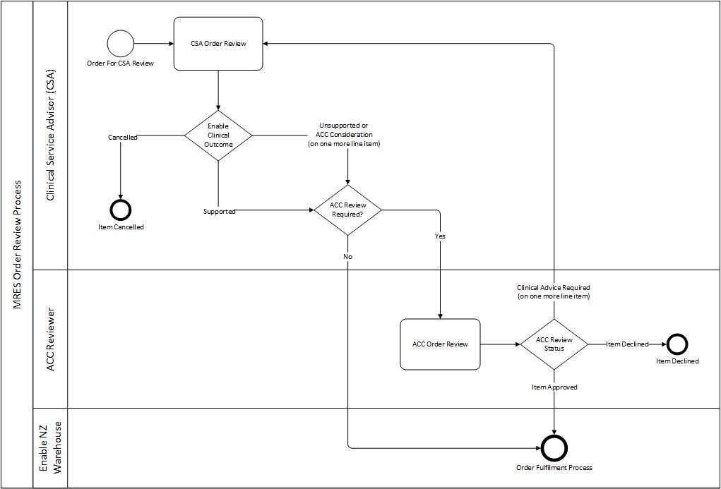

Completing a Line-Item Review & Requesting Clinical Advice
Step | Instruction | Screenshot
 | When reviewing an order, the user can no longer update the line item in the ACC Review screen, the line item must be edited to update any information.  To edit a line item, hover over the far left of the line to display the Ellipsis (…) icon, click the icon and click Edit.  The Review Items pop-up screen will be displayed. | 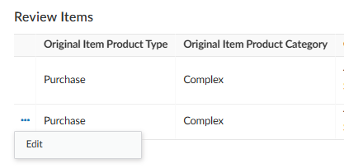
 | In the Review Items pop-up screen, the item information and outcomes are displayed. Scroll to the bottom of the screen to locate the ACC review fields.  When the information has been entered, click Update to save.  Click Cancel to return to the ACC Review Screen without any changes being made. | See Appendix 1 for full screen view  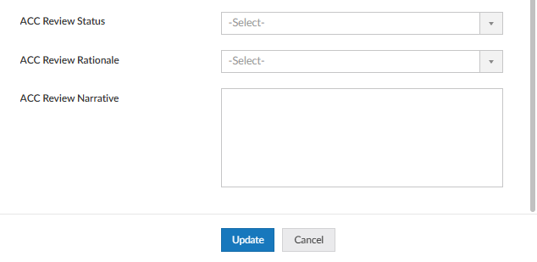
 | A new option has been added to the ACC Review Status field – Clinical Advice Required.  If the user requires clinical advice from the Enable clinical team, select this option and the order will be directed to them.  Enter a brief narrative and create a request note to Advisor with your detailed request.  Refer to MRES Notes Tutorial | 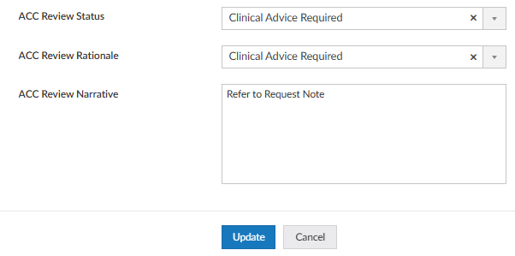
 | In ACC Review screen, in the Review Items section, the user can scroll left to right to view the line-item information as previously.

Acknowledging Request Note with a Note Subject of Enable Clinical Narrative
Step | Instruction | Screenshot
 | When reviewing an order, the user must read and acknowledge request notes with the note subject of Enable Clinical Narrative before the order can be processed.  If the Submit button is clicked and the request note has not been acknowledged, a warning dialog box will appear.  Click OK and got to Request Notes. | 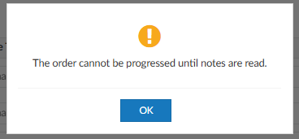
A Status column has been added.
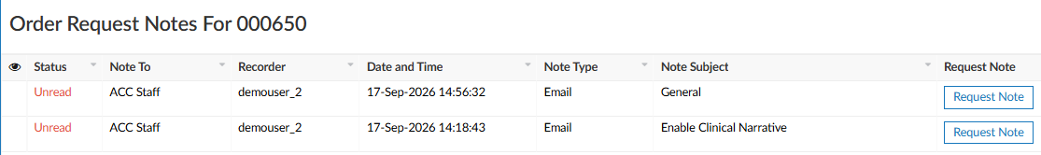
The status will only change on Request Notes with Note Subject of Enable Clinical Narrative. All other type of notes will always show a status of Unread.
Click the Request Note button on the request note line with the note subject of Enable Clinical Narrative to open the request note.
 | To acknowledge the request note has been read, check the Note Acknowledge checkbox and close the request note screen. | 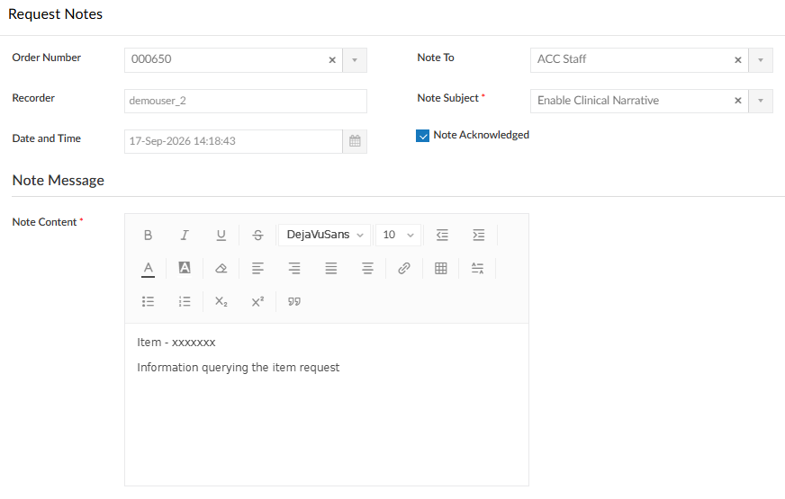
Refresh the webpage and the status will change from Unread to Read.
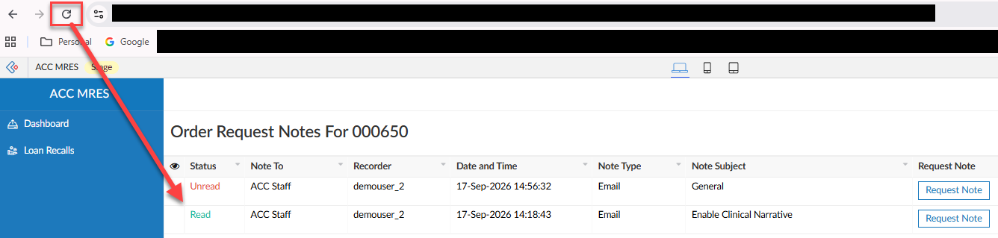
Repeat for all notes with the note subject of Enable Clinical Narrative.
The order can be processed as normal.

Reviewing the Response from Enable to an ACC Clinical Advice Required request.
Step | Instruction | Screenshot
 | When an order is reviewed and returned, the Enable Clinical Guidance field, will show  Enable Clinical Guidance Response and the response will be in a request note with the note subject of Enable Clinical Narrative.  If necessary, read and acknowledge request notes relating to the guidance response. | 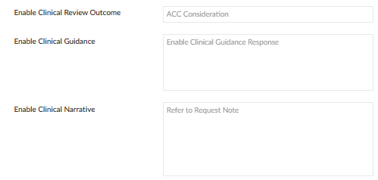
 | A line item can be substituted with a different item by the Enable clinical team.  If a line item has been substituted, the original and substitute items are displayed on the same line in the Review Items section and in the Review Items screen.  The Enable Clinical Narrative field will have a brief rationale.  The Sales Price Difference field shows the decrease/increase costing.  If necessary, read and acknowledge request notes relating to the item substitution. | See Appendix 1 for full screen view  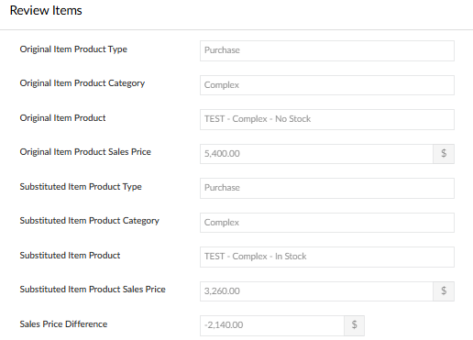
NOTE: For further clinical advice, the order can be reverted to the Enable clinical team as previous instructions.
Decline????

Appendix 1 – New Review Items Screen
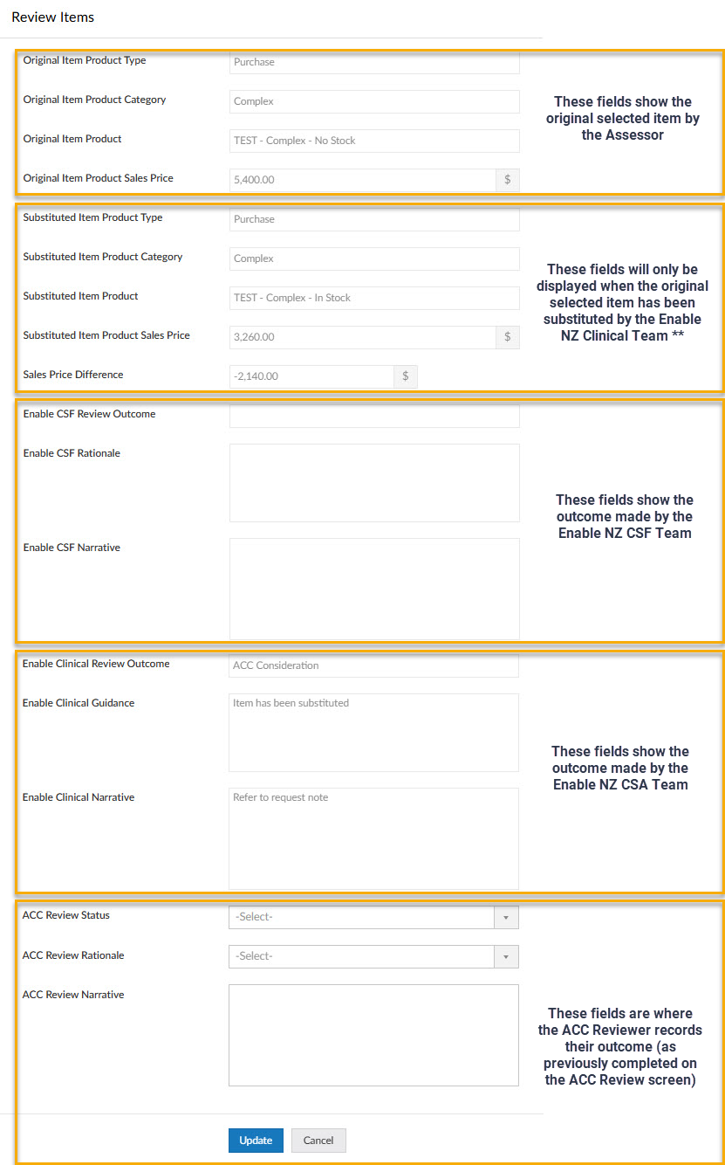
** Important: Due to software platform constraints, if an item within an order has been substituted, the substitution-related fields will be visible for all items in the order. Blank fields indicate that no substitution has been made for that specific item.

