20

Enable New Zealand ProWorkflow project management system: Login instructions
Contents
Requesting a ProWorkflow login 1
Logging in to ProWorkflow for the first time 1
Step 1. Access our ProWorkflow account 2
Step 2. Set your password and check details 2
Step 3. View ProWorkflow tutorial 3
Step 4. Set up your ProWorkflow user name 3
Step 5. Bookmark our ProWorkFlow webpage 4

Requesting a ProWorkflow login

If you have not logged on to ProWorkflow before, you will need to email a request for a login/password.
Request access to ProWorkflow
Note: You must include your name, phone number and correct work email address.
You will receive an email from ProWorkflow, with a link to login, and asking you to reset your login name and password. You have 72 hours to complete this task or you will have to request a further reset.
Important note
- ProWorkflow does not work well in Internet Explorer. Please open it in Chrome or similar.

Logging in to ProWorkflow for the first time

Step 1. Access our ProWorkflow account
In the ProWorkflow Login Details screen, click on Click To Login.
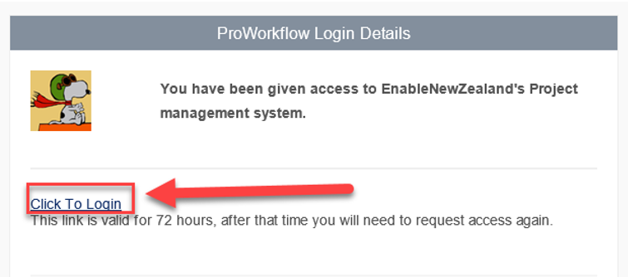
Result: The Welcome page displays.

Step 2. Set your password and check details
In the Welcome page:
- Set your password
- Check your details are correct
- Click Finished… 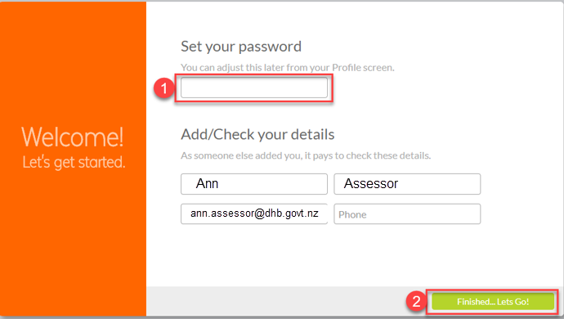
Let’s Go!

Step 3. View ProWorkflow tutorial

A quick tooltip tutorial pops up, giving you an introduction to ProWorkflow.
Step 4. Set up your ProWorkflow user name
Set up a username for when you next login.
- Click on your name at the top of the page. The ‘My Profile’ window displays.
- Update your Login Name. This can be the same as the login to get into your computer.
- Click Done!

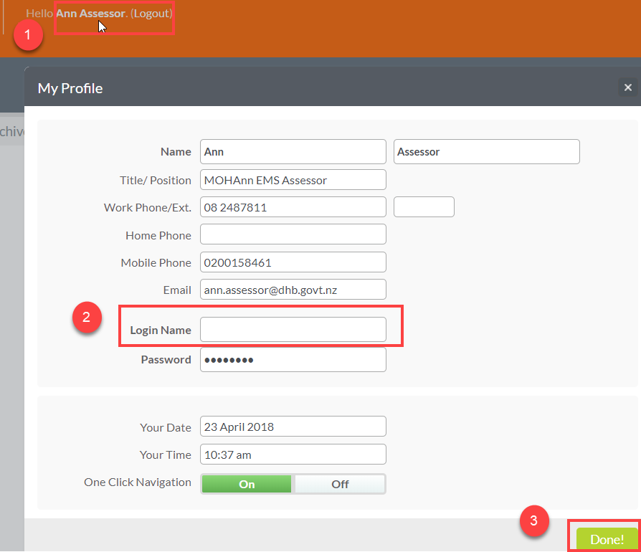
Step 5. Bookmark our ProWorkFlow webpage
To make it easy to access ProWorkflow next time, bookmark this page by clicking on the star at the end of the web address. (This is using Google Chrome).
Account URL: https://proworkflow4.net/EnableNewZealand/
When you next login, you will need to enter in your Username/Email and Password.
