Short Term Loan
User Notes

Table of Contents
Set up Multi-factor Authentication (MFA) 4
Change Password 5
Searching 6
View Inventory 6
Requests 6
Create a Request 6
Edit a Draft Request 7
Delete a Draft Request 7
Print a Request 7
Reissue 8
Dispatches 8
Print a Pick Slip 8
Assign Equipment 8
Mark as Dispatched - singular 8
Mark as Dispatched - bulk 8
Printing Loan Document 8
Edit a Dispatch Record 9
Cancel Dispatch/Request 9
Equipment 9
Add New Equipment - Scan 9
Add New Equipment – Manual 10
Edit Equipment 10
View Equipment History 10
Retire an Item 10
Return Retired Item 11
Returns 11
Move 11
Transfer 12
Recalls 13
Recalls – Edit (incl. changing Assessor) 13
Recalls – Request (Send a task to the Therapist) 13
Recalls – Action (completed by the Therapist) 13
Recalls – Print Recall Letters 13
Collections 14
Edit a Collection 14
Generating an ACC4249 14
STL-LTL Records (Replenishment) 15
Client Records 15
Add New Client 15
View/Edit Client Record 15
View Client History 15
Stock-Take 16

Versions
What | When | Who
Revised Move process (implemented Sept 2020) | March 2022 | Liz Webster
Added View Inventory | 23 Mar. 22 | Liz Webster
Full review | October 2026 | Liz Webster

Set up Multi-factor Authentication (MFA)
You do not need to reset your password. Follow the steps in order and keep your phone with you during setup.
When asked to choose an authenticator method, we recommend that you use Microsoft Authenticator and ignore OneAuth.
After setting up multi-factor authentication, you will be asked to enter a code each time you login. This code will be displayed in your Authenticator app.
Setting up MFA for the Short Term Loan app
These instructions are accurate after the MFA launch on Tuesday 21 July 2026.
- Install an Authenticator app
Download an authenticator app on your phone.
Enable NZ and Health NZ recommend you download the Microsoft Authenticator app, and use that app for this MFA.
If you are using Android, click here: Google Play Store Microsoft Authenticator App
If you are using an iPhone, click here: Apple MS Authenticator App
- Log in to STL
Open the STL app and enter your usual login details.
- QR code displayed
You will be presented with a QR code. Follow the setup steps below depending on whether you are logging in from a computer or from your phone.
- Add the code to your Authenticator app
If you are logging into STL from your computer/laptop:
Scan the QR code using your Authenticator app.
  - Open the Microsoft Authenticator app, select the QR code scan button, and point your mobile camera at the QR code on your screen.
If you are logging into STL from your phone:
Copy the 'secret key' from STL and paste into your Authenticator app.
  - Select the 'Copy' link under the QR code shown.
  - Then open Microsoft Authenticator and follow these steps:
    - Select the + button near the top of the app.
    - Select Other account.
    - In the Name field, enter Short Term Laon.
    - Press and hold on the Secret key field, then tap Paste.
    - Select Add.
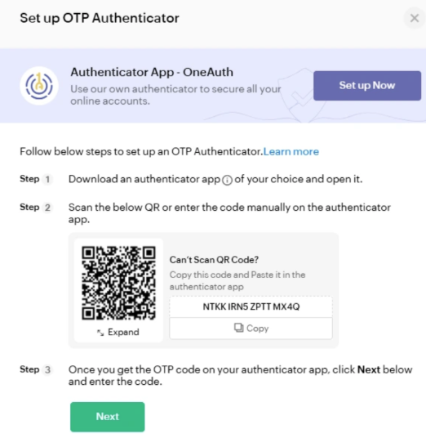
- Confirm setup
Follow the remaining steps, guided by the STL app.
- Finished!

Change Password
- Go to the STL Login screen https://shorttermloan.enable.co.nz/
- Click Forgot Password
- Enter your email address, image displayed and click Reset Password
- 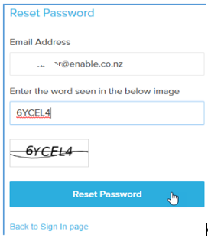
- You will be sent an email as below
- Click on the Click here link
- Complete the Password fields and click Reset Password
- 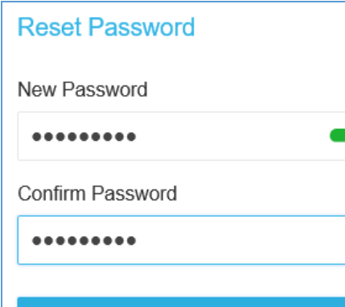
- Continue to sign in using your email and new password

Searching
Wherever there is a list of records, you may use the Search icon 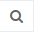 to search/filter for specific types of records you need using the columns listed. For example, in the Recall screen. You can search by the assessor name, as pictured below, or any of the columns listed under the search menu.

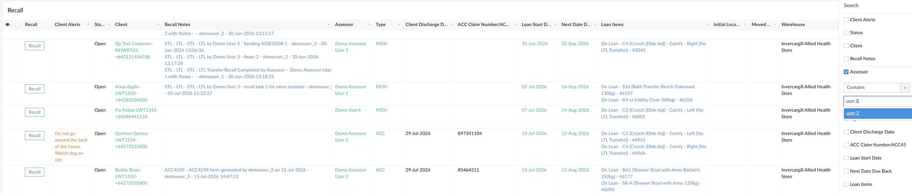

View Inventory
This can be a way of viewing what is available from your store without creating a Request.
- Inventory > View Inventory
- Click the Search icon and tick Catalogue Item
- In the field under ‘Contains’ enter part of the description of the item you are seeking
- Press the Enter key twice

Requests

Create a Request
- Dashboard > Request
- Click Add 
- Enter the Patient’s NHI
- Click in the Client field to display the client or click Add New to create a new record
- Enter the Request Type
  - If the Request Type is ACC, you will need to record the ACC45 number and Client Discharge Date
- Required Date – defaults to current but can be changed if you wish
- Select Urgency
- Catalogue Items > Add New
  - If you want equipment dispatched from another site, select the appropriate From Warehouse
  - Select a Category from the menu
  - Catalogue Item – search by typing part of the description or model code
  - Qty at Main Location = your main hospital store
  - Qty at Offsite Location = other sites linked to your hospital
  - Ship To – choose from the to select where you want it sent to
- Repeat step 8 for any additional items
- Enter Delivery instructions as required
  - record the barcode if it is already issued
  - record Ward if the Ship To is Client Ward
  - record approximate time if Client/Assessor pick-up
- Click Save as Draft
- To create a Dispatch record, click Request
- Click Yes to confirm Request

Edit a Draft Request
To edit the request while still in Draft:
- Hover to the left of the request and click the blue dots, then click Edit. 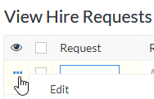
- Make any changes required
- To Cancel an item – hover to the left of the item and click
- Click Update

Delete a Draft Request
To delete a Request after it has been requested, please refer to the “Cancelling a Dispatch/Request”. This cancel task can be completed by staff who have access to the Dispatch screen.
To delete a Draft Request:
- Hover on the request and click the blank tick box to the left of the request
- Click the Delete Draft button which displays

Print a Request
- Dashboard > Request
- Hover to the left of the request record and click the tick box
- Click the Print button which displays and Print as Summary
- Click the Print button from the Print Preview screen

Reissue
Each item in your catalogue is either tagged that it can be reissued or not. Where it can’t, the Reissue button won’t be available.
- Dashboard > Reissue
- Click the Search button
  - Click the Barcode tick-box
  - Enter the barcode in the text box under the word “Contains”
  - Press the Enter key twice
- Click the Reissue button
- Select the Hire Type
- Click the Client drop down menu to search for and select your patient
- Click Submit

Dispatches

Print a Pick Slip
You can print a pick slip before and after you’ve assigned items to your dispatch record. If after, it will display the barcode numbers you have assigned.
- Dashboard > Dispatch
- Hover on the record and click the blank tick box to the left of the request
- Click the Print button which displays and Print as Summary
- Click the Print button

Assign Equipment
- Dashboard > Dispatch
- Click Assign Equipment in your record
- Click into Select Equipment and scan the equipment barcode or select from the list. You can only scan or choose items In Stock at your warehouse.
- Click Update
Once all items have a barcode assigned, you can mark the record as dispatched. The Dispatch record will go to Ready to Dispatch status and green text.

Mark as Dispatched - singular
- After assigning equipment, hover on the record and click the blank tick box to the left of the dispatch
- Click the Mark as Dispatched button which will display
- Click Yes to confirm Dispatch

Mark as Dispatched - bulk
- After assigning equipment, click the number under Ready to Dispatch on the Dashboard
- Click the All Records box and click the Mark as Dispatched button which will display
- Click Yes to confirm Dispatches

Printing Loan Document
- Dashboard > Current Loans > View Loans
- Click Search
- Click Client and enter the NHI or Name in the blank field below “Contains” and click Search
- Click the Client name and click Print and Print as Summary
- Click Print

Edit a Dispatch Record
You may be asked to edit a dispatch record for the Therapist if they want to exchange or remove an item or they have forgotten to add an item after they have submitted their Request.
- Dashboard > Dispatch
- Click the Assign Equipment button of the Dispatch record
To change an existing item:
- Select the correct Catalogue Item from the drop-down list
To cancel an existing item:
- Hover to the left of the item and click the red x
  - A message will display saying the initiating Therapist will receive an email advising them an item is being removed from the order
  - Click Okay.
To add an additional item:
- Click Add New. A message will display saying the initiating Therapist will receive an email advising them an item is being added to the order
  - Click Okay
  - Select the Catalogue Item from the drop-down list
  - Click into Select Equipment and scan the equipment barcode or select from the list.
- Click Update to save the changes.

Cancel Dispatch/Request
This Cancel Request action needs to be treated with a bit of care. This Cancel button not only deletes the Dispatch record but it deletes the whole related Request.
This is what it is designed to do but you need to ensure you have not already dispatched other items within the original Request. For example, you may have a Request with two dispatch records; one Requested and one Stock Demand. If you dispatch the Requested items and then later cancel the Stock Demand items, you will also delete the Request with the dispatched items. In this scenario you would complete the “Cancel Request Item” task.
- Dashboard > Dispatch
- Hover to the left of the dispatch line and click the blank tick box
  - Complete this action for all dispatch records relating to the Request
- Click the Cancel button which displays
- The Dispatch and Request records will be deleted
- An email will be sent to the initiating Therapist to confirm the cancellation of each item.

Equipment

Add New Equipment - Scan
- Inventory > Add New Equipment
- Scan the first QR code in the Scan Barcode
- Select the Catalogue Item from the menu
- Enter the Quantity
- Select a Warehouse Location from the menu and click Submit
If there is a Stock Demand record for this item, an Available Stock Demands screen displays:
- Click Complete Stock Demand
- Select the equipment number from the menu and click Update
The item can then be Marked as Dispatched

Add New Equipment – Manual
- Inventory > Add New Equipment
- Select Manual
- Select the Prefix Code 9401137
- Enter the first QR code in the Barcode – 8 digits
- From the Catalogue Item, press Select Equipment Tap to select choice
- Enter the Quantity
- From the Warehouse Location, press Select Equipment Tap to select choice
- Press a Warehouse Location and press Submit
If there is a Stock Demand record for this item, an Available Stock Demands screen displays as mentioned above.

Edit Equipment
This can be used to change the Model Number if the incorrect item has been recorded incorrectly against the physical item, or the Barcode has been recorded incorrectly.
- Inventory > View Equipment
- Click the Search icon 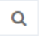and tick Barcode Gen
  - In the field under ‘Contains’ enter barcode number you are seeking, OR
  - Tick QR URL and scan the QR code
  - Press the Enter key twice
- Hover to the left of the record click … and Edit
- Update the required fields
- Click Update

View Equipment History
- Inventory > View Equipment
- Click the Search icon and tick Barcode
  - In the field under ‘Contains’ enter barcode number you are seeking, OR
  - Tick QR URL and scan the QR code
- Press the Enter key twice

Retire an Item
- Inventory > View Equipment
- Click the Search icon
  - Tick the barcode box
  - Enter the barcode number and press the Enter key twice
- Tick the box to the left of the record and click Retire
- Select a Reason from the menu and enter a Note
- Click Submit

Return Retired Item
Note: Items with a Retirement Reason of "Transferred to LTL" will not be able to be added back to stock.
- Inventory > View Equipment
- Click the Search icon
  - Tick the barcode box
  - Enter the barcode number and press the Enter key twice
- Hover to the left of the record and click the blue dots and click Edit
- Scroll down and remove the tick from the Retired box and click OK
- Add a Note and click Update

Returns
Returning equipment Dispatched from other sites
There is the ability to return any Short-Term Loan equipment which has been returned to your site. All equipment returned will continue to be put to a status of In Quarantine.
At this stage, you will only be able to Transfer the equipment from other sites back to the originating site. You will not be able to Move them into an available location at your site.
There are two ways items can be selected for returning:
- Dashboard > Return
- Ensure the cursor is in the Scan Items box, scan the QR code. OR
  - Type the barcode number and press return on your keyboard to enter any additional items
- Click Return
- Click the Select All box and click Return Item
- Ensure the number of items returned match the physical items being returned
- Click “Got It” to the confirmation message
Or
- Dashboard > Return
- Hover to the left of the record and tick the Items listed in the “Equipment On Loan” section
- Click Return Items
- Ensure the number of items returned match the physical items being returned
- Click “Got It” to the confirmation message

Move
This is for moving equipment amongst areas at your location.
- Ensure the cursor is in the Scan Items box, scan the barcodes of each item/s, Or
- Type the barcode number and press return on your keyboard to enter any additional items
- Click the Move/Transfer button
- Click the Select All box and click the Move button which displays
If you want to move all the equipment to the same location:
- Select the Location from the Bulk Destination Location menu and click Set All. This will apply the location entered in the Bulk Destination Location to the New Location fields for all equipment listed
If you want to move multiple equipment to multiple locations:
- Select the Location from the New Location field for each equipment item listed
- Click Submit
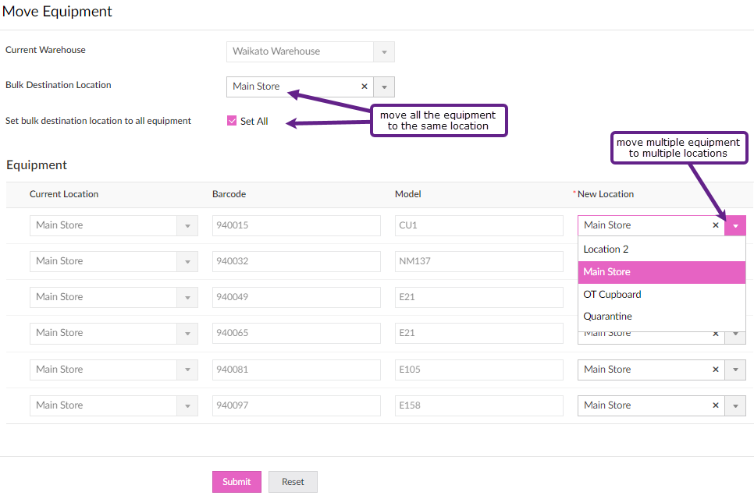

Transfer
There is the ability to record the transfer of items between hospitals with the STL system. Equipment can only be transferred to another hospital; it cannot be taken by another hospital. When you transfer the equipment, it will display in the selected hospital’s Quarantine location, and the equipment status will be In Transit.
- Dashboard > Move/Transfer
- Ensure the cursor is in the Scan Items box, scan the barcodes of each item/s, Or
  - Type the barcode number and press return on your keyboard to enter any additional items
- Click the Move/Transfer button
- Click the Select All box and click the Transfer button which displays
- Select the new Warehouse from the drop-down menu and click Submit

Recalls

Recalls – Edit (incl. changing Assessor)
- Dashboard > Recall
- Use the Search to locate the specific record
- Hover to the left of the record, click … and Edit
- Change the Request Type if required
- Change the Assessor if required
- Change the Date Due Back (to Extend) for each item if required
- Add a Contact Successful, Contact Unsuccessful or Follow-up note if required
- Click Update

Recalls – Request (Send a task to the Therapist)
- Dashboard > Recall
- Use the Search to locate the specific record
- Click the Recall button
- Click any of the 3 Recall Actions to send a task to the Therapist linked to the Recall:
  - Extension
  - Contact Patient
  - STL-LTL (Request Type must be MOH)
- Record a note to the Therapist and click Submit

Recalls – Action (completed by the Therapist)
- Dashboard > Request > Click the number under Open Recall Tasks
- Click the Action button against the client record
- Select the Recall Action you wish to complete:
Recall Action | Tasks
Extension | To remove any items from being extended, hover to the left of the record, click the X to remove the item  Enter Recall Extension Date and add a Note
STL-LTL | Ensure the Hire Request Type = MOH  To remove any items from being transferred to LT, hover to the left of the record, click the X to remove the item  Enter Eligibility details
Contact Patient | Enter a Note
- Click Submit

Recalls – Print Recall Letters
- Dashboard > Recall
- Use the Search to locate the specific record
- For one Client, click the client name, Print and Print as Summary and go to step 4
  - For multiple clients, hover to the left of each record and click the tick box
  - Click Print > Print as Summary
- Click Print

Collections
When a Collection task is created, the user is taken directly to the Collections screen.
Using the Print Status can assist you to track where in the process the Collection is at. When a Return is completed for the items in the Collection, the Collection record will automatically update the Status to Closed.

Edit a Collection
- Reports > Collections
- Click the Search icon and tick Full Name or Equipment to Collect
  - In the field under ‘Contains’ enter part of the patient’s name or the barcode of the item
  - Press the Enter key twice
- Hover to the left of the record and click the blue dots and Edit
- Update the required fields and click Update

Generating an ACC4249
For hospitals who claim from ACC post-6-week issue of STL equipment
- Dashboard > Recall
- Click the Search icon
  - Search for your patient, or
    - Tick Type and enter ACC in the text box under “Contains” and press the Enter key once
  - Tick the Next Date Due Back
  - Select your date range option from the “Is” menu and click Search
- Click the blank tick box to the left of the request
- Click the Process ACC4249 button which displays
From the ACC4249 Reports screen:
- Hover to the left of the record and click the blue dots and Edit
- Enter the ACC45 or Claim Number if known
- Select your Hospital from the menu
- Enter the Clients Acute Discharge and Hospital six-week equipment expiry date dates
- Complete the Equipment Details fields
- Click Update
- Click the Print ACC Form button
- Click on the form icon which may display at the bottom of your screen
- Click the Print icon and click the button, or Save as a PDF

STL-LTL Records (Replenishment)
There is a screen which you can use to identify items which have been requested to be transferred to long-term and which items you have received a replenishment item for.
- From the Inventory screen > View STL to LTL Transfers.
  - When a STL-LTL request is completed by the Therapist, a record is created here and displayed in red text.
- When the replenishment item is received search for the client named on the packing slip
  - Click Search
  - Tick the Client box and enter their name in the text field under “Contains”
  - Press the Enter key twice
- Hover to the left of the record and click the tick box
- Click the Mark as Completed button which displays
The record will now display in the Closed STL-LTL Transfers report in green text.

Client Records

Add New Client
- Clients > Add a Client
- Enter Name
- Enter Email, or tick ‘No Email Address’
- Enter NHI and Client DoB
- Select Gender and Client Ethnicity
- Record Client Alert if required (this info will display in Request, Dispatch, Recall and Collection records)
- Click Add New to record the client’s address (the delivery address will default to this address)
- Click Add New to record the client’s phone (the Default Phone Number will default to this)
- Click Submit
Having the Client’s address and phone details is vital for being able to Recall the equipment.

View/Edit Client Record
- Clients > View Clients
- Click the Search button and set up the search for the client record, e.g. NHI
- Hover to the left of the record, click … and Edit
- Edit changes as required and click Update
- To view Client history, click View Equipment History button in the client record

View Client History
- Clients > View Client History
- Enter the Patient’s NHI and click Search
- Click the Equipment column
- Choose sort by Descending to group the barcode records

Stock-Take
When you want to do a stock-take you can set a filter on the items to check and export the items listed into a spreadsheet.
To obtain a list for stock-taking, go to the View Equipment screen.
- Click the Search icon
  - Tick the Status box and select In Stock from the menu
  - Click outside the menu box
  - Using the other headings listed, select your options
  - If you have the same items across multiple locations, you may wish to tick the ”Warehouse Location” box and enter the location name in the text field under the “Contains” menu.
- When you have completed your search options, press the Enter key twice.
- Click the More Options icon, then Export, then Spreadsheet
Depending on your computer set-up, the spreadsheet may display at the bottom left of your screen 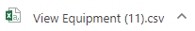
If you have found items which are not on your “In Stock” list or are missing items, search for them via the View Equipment screen.
- If the found item has a Status of “On Loan”, complete the Return and Move tasks to record them in your Store

- If the found item has a Status of “Retired”, hover to the left of the record, click the blue dots and Edit
- Untick the “Retired” box and click OK
- Click Update

- If the found item has a Status of “Transferred to LTL”, please return it to your closest Enable NZ Warehouse as this is now a Ministry of Health item

- If you have identified items missing from your “In Stock” list:
- Tick the box to the left of the record and click Retire
- Tick the “Retired” box
- Change the “Retired Date” to that of the stock-take and select the “Retirement Reason”
- Enter a Note and click Update

