Short Term Loan
Detailed User Notes

Contents
Set up Multi-factor Authentication (MFA) 4
Change Password 5
View Inventory 6
Create a request 7
Edit a Draft Request 8
Delete a Draft Request 8
Order Status 8
Print a Request 8
Reissue 9
Dashboard – Dispatch 10
Overview 10
Dispatch Status 10
Search options 11
Print a Pick Slip 11
Assign Equipment 11
Mark as Dispatched - singular 11
Mark as Dispatched - bulk 11
Printing Loan Document 12
Edit a Dispatch Record 12
Cancel Dispatch/Request 12
Add New Equipment - Scan 13
Add New Equipment – Manual 13
Edit Equipment 13
View Equipment History 14
Retire an Item 14
Return Retired Item 14
Returns 15
Move 16
Transfer 17
Recalls 17
Recall Overview 17
Recall Tasks 18
Recall Action – (incl. STL-LTL replenishment) 18
Reassign Recall records 19
Edit a Recall Record 19
Print Recall Letters 19
Merge Recall Records 20
Collections 20
Edit a Collection 20
Generating an ACC4249 21
Editing an ACC4249 21
STL-LTL Records 21
Clients 22
Add New Client 22
View/Edit Client Record 22
View Client History 22
Stock-Take 23

What | When | Who
Addition of topics: Print Pick Slip, Print Loan Document, Print Reminder Letter, Retire and Return Retired Item, Clients, Stocktake | May 2019 | Liz Webster
Complete review | July 2019 | Liz Webster
Complete review | March 2020 | Liz Webster
Revised Move process (implemented Sept 2020) | March 2022 | Liz Webster
Full review | October 2026 | Liz Webster

Set up Multi-factor Authentication (MFA)
You do not need to reset your password. Follow the steps in order and keep your phone with you during setup.
When asked to choose an authenticator method, we recommend that you use Microsoft Authenticator and ignore OneAuth.
After setting up multi-factor authentication, you will be asked to enter a code each time you login. This code will be displayed in your Authenticator app.
Setting up MFA for the Short Term Loan app
These instructions are accurate after the MFA launch on Tuesday 21 July 2026.
- Install an Authenticator app
Download an authenticator app on your phone.
Enable NZ and Health NZ recommend you download the Microsoft Authenticator app, and use that app for this MFA.
If you are using Android, click here: Google Play Store Microsoft Authenticator App
If you are using an iPhone, click here: Apple MS Authenticator App
- Log in to STL
Open the STL app and enter your usual login details.
- QR code displayed
You will be presented with a QR code. Follow the setup steps below depending on whether you are logging in from a computer or from your phone.
- Add the code to your Authenticator app
If you are logging into STL from your computer/laptop:
Scan the QR code using your Authenticator app.
  - Open the Microsoft Authenticator app, select the QR code scan button, and point your mobile camera at the QR code on your screen.
If you are logging into STL from your phone:
Copy the 'secret key' from STL and paste into your Authenticator app.
  - Select the 'Copy' link under the QR code shown.
  - Then open Microsoft Authenticator and follow these steps:
    - Select the + button near the top of the app.
    - Select Other account.
    - In the Name field, enter Short Term Laon.
    - Press and hold on the Secret key field, then tap Paste.
    - Select Add.
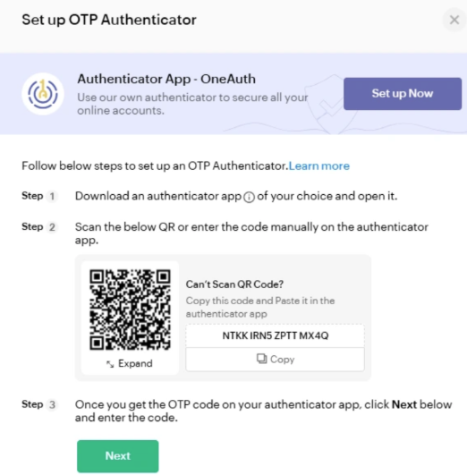
- Confirm setup
Follow the remaining steps, guided by the STL app.
- Finished!

Change Password
- Go to the STL Login screen https://shorttermloan.enable.co.nz/
- Click Forgot Password
- Enter your email address, image displayed and click Reset Password
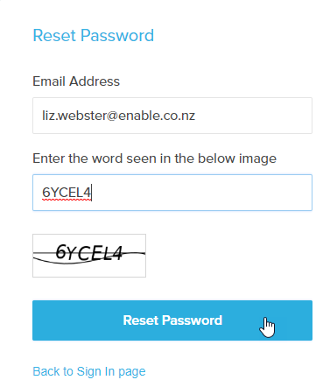
- You will be sent an email as below
- Click on the Click here link
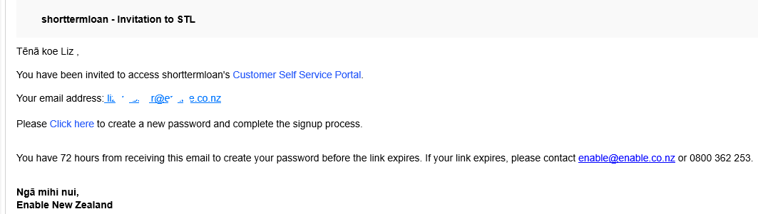
- Complete the Password fields and click Reset Password
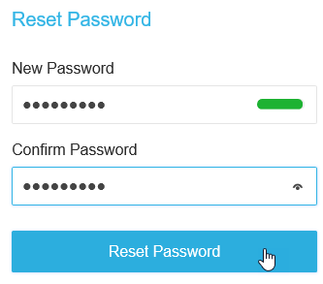
- Continue to sign in using your email and new password.

View Inventory
This can be a way of viewing what is available from your store without creating a Request.
- Inventory > View Inventory
- Click the Search icon 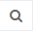 and tick Catalogue Item
- In the field under ‘Contains’ enter part of the description of the item you are seeking
- Press the Enter key twice

Create a request
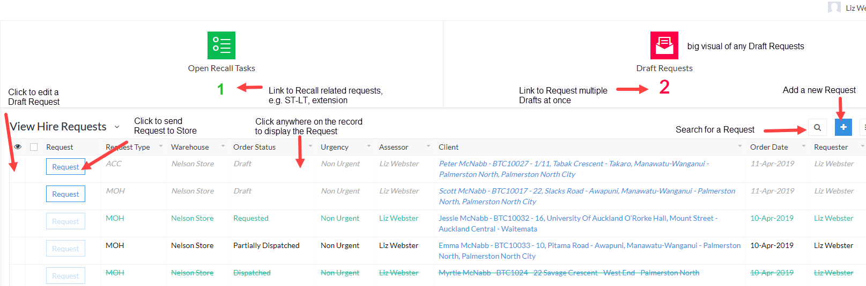
Minimum requirement to save as a Draft is Client Name and 1 item
- Dashboard > Request
- Click Add 
- Enter the Patient’s NHI
- Click in the Client field to display the client or click Add New to create a new record
- Enter the Request Type
  - defaults to MOH but can select others. The loan timeframe is derived by the Type
  - if the Request Type is ACC, you will need to record the ACC45 number and Client Discharge Date
- Dates – default to current but can be changed if you wish
- Assessor – defaults to logged-in user. Click to search for another Assessor name if completing this on behalf of the Therapist. Any Recall tasks will go to the Assessor listed in this request.
- Urgency – in the Dispatch dashboard, Urgent will display the record in Red and have a count under Urgent
- Catalogue Items > Add New
  - If you want equipment dispatched from another site, select the appropriate From Warehouse
  - Select a Category from the menu
  - Catalogue Item – search by typing part of the description or model code
  - Qty at Main Location = your main hospital store
  - Qty at Offsite Location = other sites linked to your hospital
  - Ship To – choose from the to select where you want it sent to
- Repeat step 9 for any additional items
- A separate dispatch record will be created for:
  - Different Ship To options
  - 0 amount at Main Location – (Stock Demand dispatch record)
- Enter Delivery instructions as required
  - record the barcode if it is already issued
  - record Ward name if the Ship To is Client Ward
  - record approximate time if Client/Assessor pick-up
- Click Save as Draft
When a request is saved, it is saved as a draft. This enables you to make any edits before submitting it to become a dispatch record.
The request will show in the dashboard in red as a Draft until it is “requested”.

- To create a Dispatch record, click Request
- Click Yes to confirm Request
Notes:
Once the Request is submitted, it cannot be changed.
You can copy an Order by hovering to the left of the record and ticking the box, then click Copy.

Edit a Draft Request
To edit the request while still in Draft:
- Hover to the left of the request and click the blue dots, then click Edit. 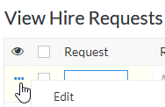
- Make any changes required
- To Cancel an item – hover to the left of the item and click
- Click Update

Delete a Draft Request
To delete a Request after it has been requested, please refer to the “Cancelling a Dispatch/Request”.
To delete a Draft Request:
- Hover to the left of the request and click the tick box to the left of the request
- Click the Delete Draft button which displays.

Order Status
Status | Description
Draft | Can be edited by the Assessor  Request has not yet been sent to Store
Requested | A dispatch record is displayed for Store
Partially Dispatched | Some of the items requested have been dispatched by the Store while there are others on Stock Demand
Dispatched | All items requested have been dispatched

Print a Request
- Dashboard > Request
- Hover to the left of the request record and click the tick box
- Click the Print button which displays and Print as Summary
- Click the Print button from the Print Preview screen

Reissue
Search options
– Search Options: you can set your search options by any of the headings in the grid, e.g. to display by Client or Barcode.
Sometimes, you may deliver an item to a client, and they decide they don’t want/need it. If you have another client who needs the same item and the item meets hygiene and safety measures, it can be reissued to another client without going through the inwards goods / create new request process.
Each item in your catalogue is either tagged that it can be reissued or not. Where it can’t, the Reissue button won’t be available.
Please ensure you check the Hire Type as this will decide the loan period, if it can be transferred to DSS or billed to ACC.
- Dashboard > Reissue
- Click the Search icon
  - Tick the Barcode Gen and type the barcode number in the field under “Contains”, OR
  - Press the QR URL and scan the QR code in the field under “Contains”
  - Press the Enter key twice
- Click the Reissue button
- Change the Hire Type if required
- Click the Client drop down menu to search for and select your patient
- Click Submit
This action will:
- Cancel the existing return record and create a new return record for the new Client
- Cancel the existing Recall record and create a new Recall record for the new Client
- Cancel the existing Reissue record and create a new Reissue record for the new Client
- Client History’s will show reissue to and from clients

Dashboard – Dispatch
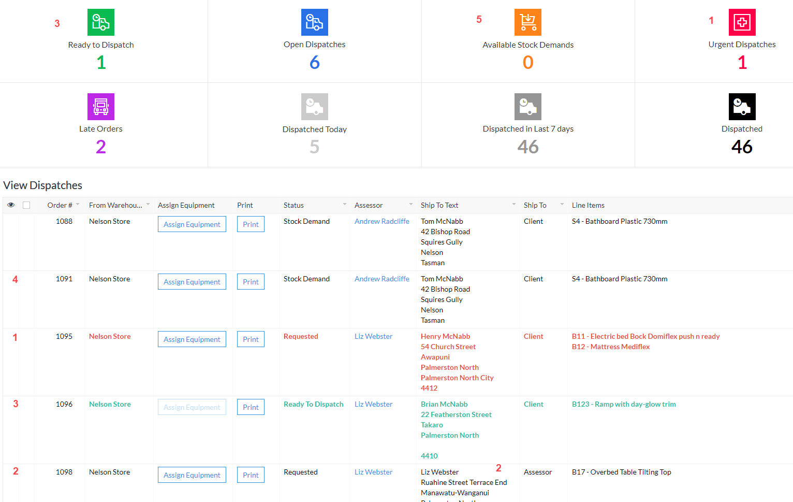

Overview
There are two parts to dispatching Short Term Loan equipment; the first is assigning the actual barcodes to the items requested and the second, marking the record as Dispatched. This second part:
- removes the dispatch record from the dispatch list
- changes the original request Status to Dispatched
- creates a Return record so it can be returned
- creates a Recall/Loan record to manage the recall of the equipment
- creates a Reissue record to allow the Therapist to transfer the item from one patient to another
- updates the Client History as dispatched to that Client
- updates the Inventory count and displays in View Equipment as On Loan
- displays a record in Current Loans > View Loans where a loan document can be printed
The records with a Status of Requested have requested items which are available in your store and are ready to dispatch.
The records with a Status of Stock Demand have requested items which are not available.
The Ship To column will advise you where the Therapist would like the equipment delivered to. The Delivery Instructions will provide further information regarding the request. For example, which pick-up time if “Pickup Client” has been chosen as the Ship To option or the barcode number if the item has already been physically issued.

Dispatch Status
1 | Requested Assign Equipment – Urgent, waiting to have items assigned, displayed in Red
2 | Requested Assign Equipment - waiting to have items assigned, deliver to Assessor
3 | Ready to Dispatch – items assigned, ready to dispatch and create loan record
4 | Stock Demand – item not currently available in your warehouse
5 | Available Stock Demands – when there is a Stock Demand dispatch record and there is now an item available to complete the dispatch

Search options
– Search Options: you can set your search options by any of the headings in the grid, e.g. to display only your dispatch records, search by yourself as the Assessor; to search for a client, search by Ship To Text.

Print a Pick Slip
You can print a pick slip before and after you’ve assigned items to your dispatch record. If after, it will display the barcode numbers you have assigned.
- Dashboard > Dispatch
- Hover on the record and click the tick box to the left
- Click the Print button which displays and Print as Summary
- Click the Print button

Assign Equipment
- Dashboard > Dispatch
- Click Assign Equipment in the dispatch record
- Scan the QR code in the Scan Barcode field, or
  - Select the barcode of the item being dispatched from Select Equipment
- Click Update
Once all items have a barcode assigned, you can mark the record as dispatched. The Dispatch record will go to Ready to Dispatch status and green text.

Mark as Dispatched - singular
- After assigning equipment, hover on the record and click the tick box to the left
- Click the Mark as Dispatched button and Yes to confirm Dispatch

Mark as Dispatched - bulk
- After assigning equipment, click the number under Ready to Dispatch on the Dashboard
- Click the All Records box and click the Mark as Dispatched button and Yes to confirm Dispatch
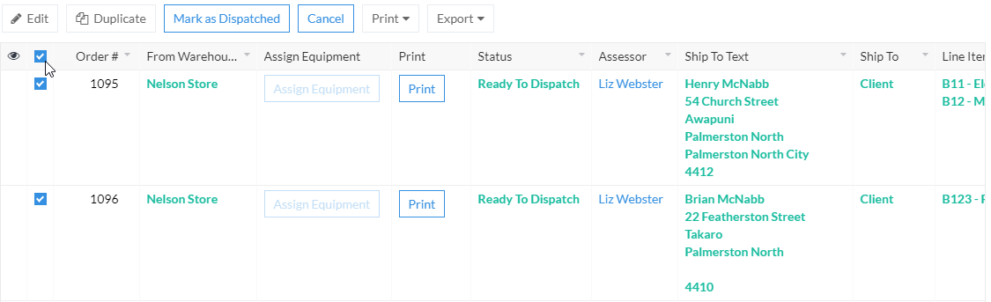
This action will display a record in the:
- Returns view as Equipment on Loan so they can be returned
- Recall view to enable a Recall Request (extension, STL-LTL, etc.) and where a recall document can be printed
- Reissue view
- Client History as dispatched to that Client
- View Inventory and View Equipment as On Loan
- Current Loans > View Loans (where a loan document can be printed)

Printing Loan Document
- Dashboard > Current Loans > View Loans
- Click Search
- Click Client and enter the NHI or Name in the blank field below “Contains” and click Search
- Click the Client name and click Print and Print as Summary
- Click Print

Edit a Dispatch Record
You may be asked to edit a dispatch record for the Therapist if they want to exchange or remove an item or they have forgotten to add an item after they have submitted their Request.
- Dashboard > Dispatch
- Click the Assign Equipment button of the Dispatch record
To change an existing item:
- Select the correct Catalogue Item from the drop-down list
To cancel an existing item:
- Hover to the left of the item and click the red x
To add an additional item:
- Click Add New
  - Select the Catalogue Item from the drop-down list
- Click Update to save the changes.

Cancel Dispatch/Request
This Cancel Request action needs to be treated with a bit of care. This Cancel button not only deletes the Dispatch record, but it deletes the whole related Request.
These are the checks to complete before cancelling the Request and Dispatch record:
- Check with the Therapist to ensure they want the whole request deleted
- If yes, confirm the items and the date requested

- Check the Dispatch screen to see if all the items requested are displayed
  - If all the items don’t display, click the “Dispatched” number
  - Search for the Client
  - If there are dispatch records with the items and the same Requested Date, complete the “Cancel Request Item” task
  - Click the White X to close this screen
- If the Dispatch records do display all the items, they can be cancelled
To cancel the Request and Dispatch record:
- Dashboard > Dispatch
- Hover to the left of the dispatch line and click the blank tick box
  - Complete this action for all dispatch records relating to the Request
- Click the Cancel button which displays
- The Dispatch and Request records will be deleted
- An email will be sent to the initiating Therapist to confirm the cancellation of each item.

Add New Equipment - Scan
When you get new equipment, you can add it to Inventory. Where there is a Stock Demand dispatch record for the newly created item, a pop-up will display to take you to a screen which will enable you to dispatch the Stock Demand.
- Inventory > Add New Equipment
- Scan the first QR code in the Scan Barcode
- Select the Catalogue Item from the menu
- Enter the Quantity
- Select a Warehouse Location from the menu and click Submit
If there is a Stock Demand record for this item, an Available Stock Demands screen displays:
- Click Complete Stock Demand
- Select the equipment number from the menu and click Update
The item can then be Marked as Dispatched

Add New Equipment – Manual
- Inventory > Add New Equipment
- Select Manual
- Select the Prefix Code 9401137
- Enter the first QR code in the Barcode – 8 digits
- From the Catalogue Item, press Select Equipment Tap to select choice
- Enter the Quantity
- From the Warehouse Location, press Select Equipment Tap to select choice
- Press a Warehouse Location and press Submit
If there is a Stock Demand record for this item, an Available Stock Demands screen displays as mentioned above.

Edit Equipment
This can be used to change the Model Number if the incorrect item has been recorded incorrectly against the physical item, or the Barcode has been recorded incorrectly.
- Inventory > View Equipment
- Click the Search icon and tick Barcode Gen
  - In the field under ‘Contains’ enter barcode number you are seeking, OR
  - Tick QR URL and scan the QR code
  - Press the Enter key twice
- Hover to the left of the record click … and Edit
- Update the required fields
- Click Update

View Equipment History
- Inventory > View Equipment
- Click the Search icon and tick Barcode
  - In the field under ‘Contains’ enter barcode number you are seeking, OR
  - Tick QR URL and scan the QR code
- Press the Enter key twice

Retire an Item
If you realise the item is no longer fit for purpose or has been lost, it can be retired. Retired items, except for those transferred to LTL, can be restored and added to inventory; e.g. item found.
- Inventory > View Equipment
- Click the Search icon
  - Tick the Barcode Gen and type the barcode number in the field under “Contains”, OR
  - Press the QR URL and scan the QR code in the field under “Contains”
- Press the Enter key twice
- Hover to the left of the record, and tick the box
- Click Retire
- Select a Reason from the menu and enter a Note
- Click Submit
– Search Options: you can set your search options by any of the headings in the grid, e.g. to display by Retired

Return Retired Item
- Inventory > View Equipment
- Click the Search icon
  - Tick the Retired box and click Search
- Hover to the left of the record and click the blue dots and click Edit
- Remove the tick from the Retired box and click OK
- Add a Note and click Update

Returns
The return items function does the following:
- Reissue/Recall/Loan – Removes any records for that item
- Client History – records the return of an item
- Inventory – subtracts 1 from On Loan and adds it to In Quarantine
- View Equipment – changes the Status of the equipment from On Loan to In Quarantine
In a request, the item won’t display in the count as “At Main Location” until it is Moved to an In Stock location.

Returning equipment Dispatched from other sites
There is the ability to return any Short-Term Loan equipment which has been returned to your site. All equipment returned will continue to be put to a status of In Quarantine.
At this stage, you will only be able to Transfer the equipment from other sites back to the originating site. You will not be able to Move them into an available location at your site.
There are two ways items can be selected for returning:
- Dashboard > Return
- Ensure the cursor is in the Scan Items box, scan the QR code. OR
  - Type the barcode number and press return on your keyboard to enter any additional items
- Click Return
- Click the Select All box and click Return Items
- Ensure the number of items returned match the physical items being returned
- Click “Got It” to the confirmation message
Or
- Dashboard > Return
- Hover to the left of the record and tick the Items listed in the “Equipment On Loan” section
- Click Return Items
- Ensure the number of items returned match the physical items being returned
- Click “Got It” to the confirmation message

Move
Items can be moved from one location to another within a warehouse. The most common being moving the item from Quarantine, after cleaning, to an In Stock location where it can be seen as available in a request.
- Ensure the cursor is in the Scan Items box, scan the barcodes of each item/s, Or
  - Type the barcode number and press return on your keyboard to enter any additional items
- Click the Move/Transfer button
- Click the Select All box and click the Move button which displays
If you want to move all the equipment to the same location:
- Select the Location from the Bulk Destination Location menu and click Set All. This will apply the location entered in the Bulk Destination Location to the New Location fields for all equipment listed
If you want to move multiple equipment to multiple locations:
- Select the Location from the New Location field for each equipment item listed
- Click Submit
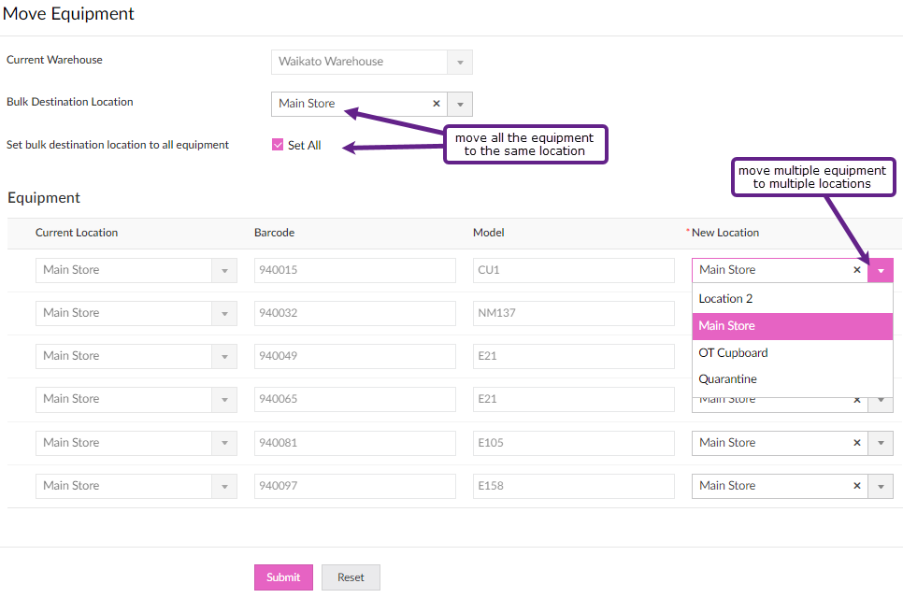

Transfer
There is the ability to record the transfer of items between hospitals with the STL system. Equipment can only be transferred to another hospital; it cannot be taken by another hospital. When you transfer the equipment, it will display in the selected hospital’s Quarantine location, and the equipment status will be In Transit.
- Dashboard > Move/Transfer
- Ensure the cursor is in the Scan Items box, scan the barcodes of each item/s, Or
  - Type the barcode number and press return on your keyboard to enter any additional items
- Click the Move/Transfer button
- Click the Select All box and click the Transfer button which displays
- Select the new Warehouse from the drop-down menu and click Submit

Recalls
– Search Options: you can set your search options by any of the headings in the grid, e.g. to display by Client, Items Due Back date and/or Assessor.

Recall Overview
Because the request to Recall may come from a Storeperson or an Assessor, there are two actions to complete a Recall:
- Recall Request
- Action Recall
Recall Request
Action selected | System action
Contact Patient Successful/Unsuccessful  Follow-up | A Recall note will be added to the Recall record  Creates a recall note and enables searching by follow-up
Extension, STL-LTL or Contact Patient – add Note and Submit | A task will go to the Assessor assigned to the Recall record for them to action.  These are displayed in the Request Dashboard – Open Recall Tasks
Collection | Creates a Collection record

Recall Action
Action selected | System action
Extension – Change the Recall Extension Date, add a Note (optional) and Submit | The Recall record’s Item Due Back Date will change to the new date entered and any note will be displayed.  The Open Recall Task is removed
STL-LTL – ensure the Request Type = MOH, enter eligibility details and Submit | The Recall record is removed  The items are retired with a status of Transferred to LTL.  This item cannot be returned to STL using the same barcode.  The Equipment History will display it has been transferred to LTL  The details are sent to Enable NZ to request a LTL replenishment item  The Open Recall Task is removed  The STL-LTL details can be viewed via Inventory > View STL-LTL Transfers
Contact Patient – add a Note and Submit | A Recall note will be added to the Recall record

Recall Tasks
If you are not the initiating Therapist but you have approval to extend the Recall date, please refer to the Edit a Recall Record.
To request an Extension, STL to LTL replenishment or Contact Patient against the Recall record:
- Click the Recall button against the relevant record
  - For STL to LTL requests, please ensure the Request Type for the patient is MOH.
  - Only items ticked “Transfer Allowed” can be transferred from Short to Long Term
- Click the relevant Recall Action radio button and enter a note in the Notes field,
- Click Submit.
Note:
Extension – if there are multiple items listed and you want to extend only some, hover to the left of the item and click to remove the item from the Extension request. It does not remove the item from the Recall record.
Collection - if there are multiple items listed and you want to collect only some, hover to the left of the item and click to remove the item from the Collection request. It does not remove the item from the Recall record.
STL-LTL – When choosing STL-LTL, and there are items not ticked as “Transferred Allowed”, hover to the left of the item and click to remove the item. It does not remove the item from the Recall record.

STL-LTL – When choosing STL-LTL, only Request Type of MOH can be transferred to DSS.
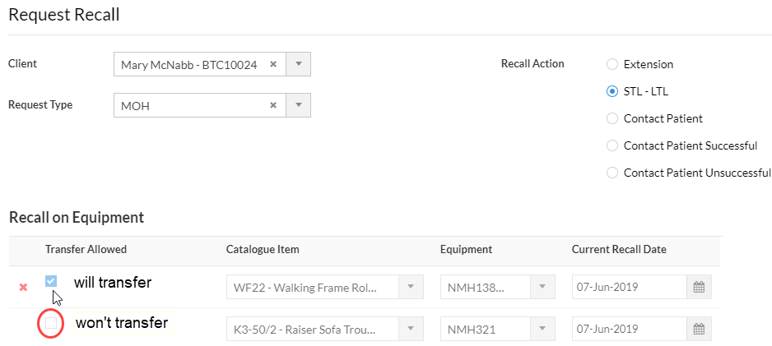

Recall Action – (incl. STL-LTL replenishment)
- Dashboard > Request > click the number under “Open Recall Tasks”
- Click Action on the record
- Select the Recall Action you wish to complete:
Recall Action | Tasks
To remove any items from the list of items | hover to the left of the record, click the X to remove the item
Extension | Enter Recall Extension Date and add a Note
STL-LTL | Ensure the Hire Request Type = MOH  To remove any items from being transferred to LT, hover to the left of the record, click the X to remove the item  Enter Eligibility details
Contact Patient | Enter a Note
- Click Submit

Reassign Recall records
Reassigning Recall records is to enable transferring caseloads from one Therapist to another.
- Reassigning is completed via the Recall screen.
- Click the Search icon
  - Tick the Assessor box and enter the original Therapist’s name in the text field under the “Contains” drop down menu
  - Press the Enter key twice
- Click the Select All box and click the Edit button
- From the drop-down menu in the text box, select “Assessor”
- From the Assessor menu, select the name of the Therapist to reassign the record to
- Click Apply and click Yes to confirm the edit
- The selected Recall records will now have the new Therapist name displayed

Edit a Recall Record
- Dashboard > Recall
- Search and locate the required Recall record
  - Click the Search icon
  - Tick the Client box
  - Enter the patient NHI in the field under the word “Contains”
  - Press the Enter key twice
- Hover to the left of the record, click the blue dots and click Edit.
- To edit the Request Type
  - Select the option from the menu and click Okay to the warning

- To extend the Recall date, edit the Date Due Back of the item

- To add a Recall Note, click Add New in the Recall Notes area
  - Select the type of note from the drop-down menu
  - Record your note
- Once you have made changes, click Update

Print Recall Letters
- Dashboard > Recall
- Click Search to search for any recall record using these headings.
  - For example, click Next Date Due Back
  - Click “Is ” and select the timeframe to search, e.g. Current or Next Week
  - Click Search
- Hover to the left of the record, and tick the box
- Click Print and Print as Summary
- Click Print

Merge Recall Records
Separate Recall records happen when the Request has a mix of available and Stock Demand items. This type of Request creates two separate Dispatch records and therefore two separate Recall records once they are all dispatched.
Another example may be where the Occupational Therapist has done a request for a patient and a Physiotherapist has completed a separate request for the same patient within a similar timeframe.
Note: Once Merged they cannot be undone.
The Merge option is in the Recall screen.
- Press Search
  - Press Client and enter the NHI or Name in the blank field below “Contains”
  - Press the Enter key twice
- Check the Client Name, NHI and Type are the same for each record
- Check to ensure the Next Dates Due are within a similar timeframe
- Tick the records to merge and click the Merge button which will display
- Click one of the names from the “Select Loan to Merge Into” drop down menu
- Double-check the Name details
- Click Submit

Collections
When a Collection task is created, the user is taken directly to the Collections screen.
Using the Print Status can assist you to track where in the process the Collection is at. When a Return is completed for the items in the Collection, the Collection record will automatically update the Status to Closed.

Edit a Collection
- Reports > Collections
- Click the Search 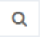 icon and tick Full Name or Equipment to Collect
  - In the field under ‘Contains’ enter part of the patient’s name or the barcode of the item
  - Press the Enter key twice
- Hover to the left of the record and click the blue dots and Edit
- Update the required fields and click Update

Generating an ACC4249
For hospitals who claim from ACC post-6-week issue of STL equipment
- Dashboard > Recall
- Click the Search icon
  - Search for your patient, or
    - Tick Type and enter ACC in the text box under “Contains” and press the Enter key once
  - Tick the Next Date Due Back
  - Select your date range option from the “Is” menu and click Search
- Click the blank tick box to the left of the request
- Click the Process ACC4249 button which displays
From the ACC4249 Reports screen:
- Hover to the left of the record and click the blue dots and Edit
- Update the 4249 Status to Printed
- Enter the Sent to ACC date
- Enter the Clients Acute Discharge Date
- Complete the Equipment Details fields
- Click Update
- Hover to the left of the record and click the blue dots and PDF/Print
- Click the Print or PDF

Editing an ACC4249
Using the 4249 Status, Followed up with ACC and Notes section can assist you to track where in the process the ACC4249 is at.
Text recorded in the Comments section will display on the ACC4249 form.

STL-LTL Records
There is a screen which you can use to identify items which have been requested to be transferred to long-term and which items you have received a replenishment item for.
- From the Inventory menu > View STL to LTL Transfers
  - When a STL-LTL request is completed by the Therapist, a record is created here and displayed in red text
- When the replenishment item is received search for the client named on the packing slip
  - Click Search
  - Tick the Client box and enter their NHI in the text field under “Contains”
  - Press the Enter key twice
- Hover to the left of the record and click the tick box
- Click the Mark as Completed button which displays
This action will remove the record from the list, indicating you have received the replenishment item.
To view replenished STL-LTL records, go to Inventory menu > Closed STL to LTL Transfers.

Clients
As well as adding new clients from within a request, this can also be done separate to a request.
View Clients is where you view their contact details and edit if required. It also provides a link to the client’s equipment history.
View Client History is a direct view of client’s equipment history.

Add New Client
- Clients > Add a Client
- Enter Name and Email (if provided)
- Enter NHI and Client DoB
- Select Gender and Client Ethnicity
- Record Client Alert if required (this info will display in Request, Dispatch, Recall and Collection records)
- Click Add New to record the client’s address (the delivery address will default to this address)
- Click Add New to record the client’s phone (the Default Phone Number will default to this)
- Click Submit
Having the Client’s address and phone details is vital for being able to Recall the equipment.

View/Edit Client Record
- Clients > View Clients
- Enter the client’s NHI and press Search
- Hover to the left of the record, click … and Edit
- Edit changes as required and click Update
- To view Client history, click View Equipment History button in the client record

View Client History
- Clients > View Client History
- Enter the client’s NHI and press Search

Stock-Take
When you want to do a stock-take you can set a filter on the items to check and export the items listed into a spreadsheet.
- To obtain a list for stock-taking, go to the View Equipment screen.
- Click the Search icon
  - Tick the Status box and select In Stock from the menu
  - Click outside the menu box
  - Using the other headings listed, select your options
  - If you want to stock-take a specific item, tick the Model Number box and enter the model in the text field under the “Contains” menu
  - When you have completed your search options, press the Enter key twice.
- Click the More Options icon, then Export, then XLSX
- De-select any columns you don’t require
- Click Export
Depending on your computer set-up, the spreadsheet may display at the top left of your screen 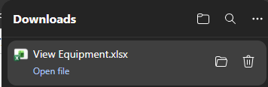
If you have found items which are not on your “In Stock” list or are missing items, search for them via the View Equipment screen:
- If the found item has a Status of “On Loan”, complete the Return and Move tasks to record them in your Store

- If the found item has a Status of “Retired”, refer to Return Retired Item

- If the found item has a Status of “Transferred to LTL”, please return it to your closest Enable NZ Refurbishment Centre as this is now a DSS item

- If you have identified items missing from your “In Stock” list, refer to Retire an Item

These actions will update the Inventory counts.

