Short Term Loan
Detailed User Notes
for
iPads

Contents
Adding the STL App on your iPad 4
User Account Details 4
Set up Multi-factor Authentication (MFA) 5
Change Password 6
View Inventory 7
Create a request 8
Edit a Draft Request 9
Delete a Draft Request 9
Order Status 10
Print a Request 10
Reissue 10
Dashboard – Dispatch 11
Overview 11
Dispatch Status 12
Search options 12
Print a Pick Slip 12
Assign Equipment 12
Mark as Dispatched - singular 12
Mark as Dispatched - bulk 13
Printing Loan Document 13
Edit a Dispatch Record 13
Cancel Dispatch/Request 15
Add New Equipment - Scan 15
Add New Equipment – Manual 16
Edit Equipment 16
View Equipment History 16
Retire an Item 16
Return Retired Item 17
Returns 17
Move 18
Transfer 19
Recalls 20
Recall Overview 20
Recall Tasks 20
Recall Action – (incl. STL-LTL replenishment) 20
Recall Tasks 20
Recall Action – (incl. STL-LTL replenishment) 21
Reassign Recall records 22
Edit a Recall Record 22
Print Recall Letters 22
Merge Recall Records 23
Collections 23
Edit a Collection 23
Generating an ACC4249 24
Editing an ACC4249 24
STL-LTL Records 24
Clients 25
Add New Client 25
View/Edit Client Record 25
View Client History 25
Stock-Take 26

What | When | Who
Addition of topics: Print Pick Slip, Print Loan Document, Print Reminder Letter, Retire and Return Retired Item, Clients, Stocktake | May 2019 | Liz Webster
Complete review | July 2019 | Liz Webster
Complete review | March 2020 | Liz Webster
Revised Move process (implemented Sept 2020) | March 2022 | Liz Webster
Full review | September 2026 | Liz Webster

Adding the STL App on your iPad
- From the Apple App Store search: customer portal – Zoho creator
- Press Get
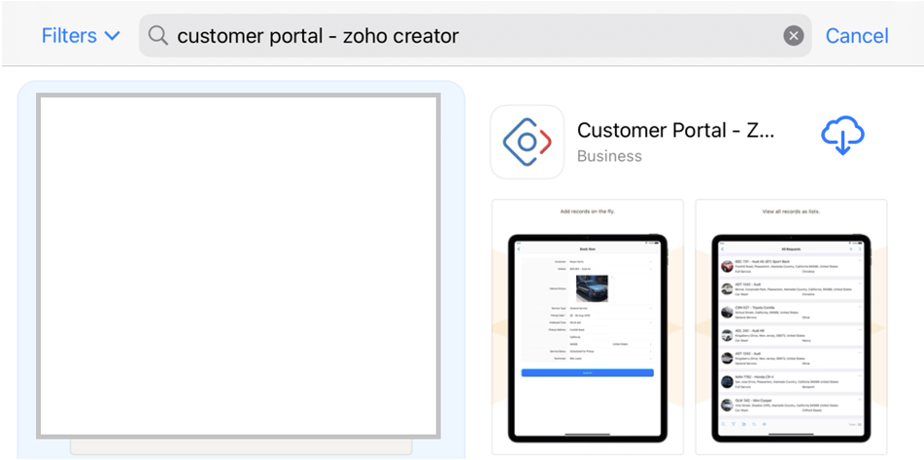
- Press Open
- Enter Portal URL: https://shorttermloan.enable.co.nz/
- Press Proceed
- Enter you Email Address and press Next
- Enter your password and press Sign In
- Go to your authenticator app, selecting Enable+Short+Term+Lo
- Enter the One-time password code and press Verify
- Press Trust
- Press Don’t allow for notifications

User Account Details
The Account Settings on the STL app on your iPad is not to be used. The feedback and support will go to the Zoho community and will not be able to resolve any issues/questions you may have.
To set up or change your password and set up the MFA, you will need to do this on a laptop or computer.

Set up Multi-factor Authentication (MFA)
You do not need to reset your password. Follow the steps in order and keep your phone with you during setup.
When asked to choose an authenticator method, we recommend that you use Microsoft Authenticator and ignore OneAuth.
After setting up multi-factor authentication, you will be asked to enter a code each time you login. This code will be displayed in your Authenticator app.

Setting up MFA for the Short Term Loan app
These instructions are accurate after the MFA launch on Tuesday 21 July 2026.
- Install an Authenticator app
Download an authenticator app on your phone.
Enable NZ and Health NZ recommend you download the Microsoft Authenticator app, and use that app for this MFA.
If you are using Android, click here: Google Play Store Microsoft Authenticator App
If you are using an iPhone, click here: Apple MS Authenticator App
- Log in to STL
Open the STL app and enter your usual login details.
- QR code displayed
You will be presented with a QR code. Follow the setup steps below depending on whether you are logging in from a computer or from your phone.
- Add the code to your Authenticator app
If you are logging into STL from your computer/laptop:
Scan the QR code using your Authenticator app.
  - Open the Microsoft Authenticator app, select the QR code scan button, and point your mobile camera at the QR code on your screen.
If you are logging into STL from your phone:
Copy the 'secret key' from STL and paste into your Authenticator app.
  - Select the 'Copy' link under the QR code shown.
  - Then open Microsoft Authenticator and follow these steps:
    - Select the + button near the top of the app.
    - Select Other account.
    - In the Name field, enter Short Term Laon.
    - Press and hold on the Secret key field, then tap Paste.
    - Select Add.
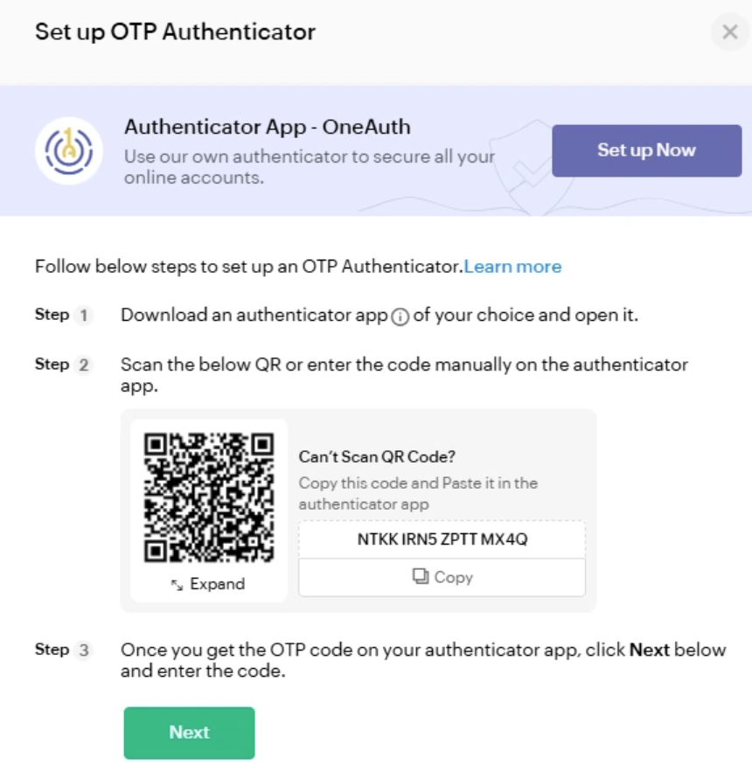
- Confirm setup
Follow the remaining steps, guided by the STL app.
- Finished!

Change Password
- Go to the STL Login screen https://shorttermloan.enable.co.nz/
- Click Forgot Password
- Enter your email address, image displayed and click Reset Password
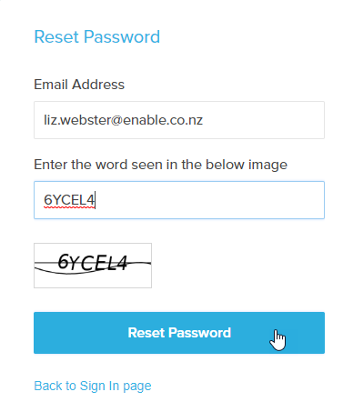
- You will be sent an email as below
- Click on the Click here link
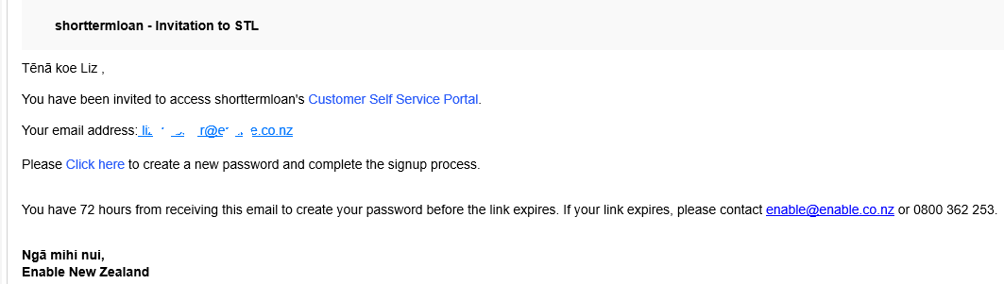
- Complete the Password fields and click Reset Password
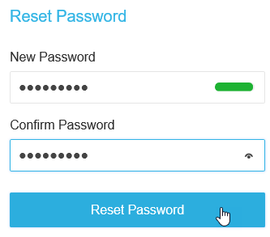
- Continue to sign in using your email and new password.

View Inventory
This can be a way of viewing what is available from your store without creating a Request.
- Inventory > View Inventory
- Press the Search icon 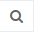 and tick Catalogue Item
- In the field under ‘Contains’ enter part of the description of the item you are seeking
- Press Apply
- Scroll right to view more information
- My Warehouse only and All Warehouses in My DHB tabs don’t filter

Create a request

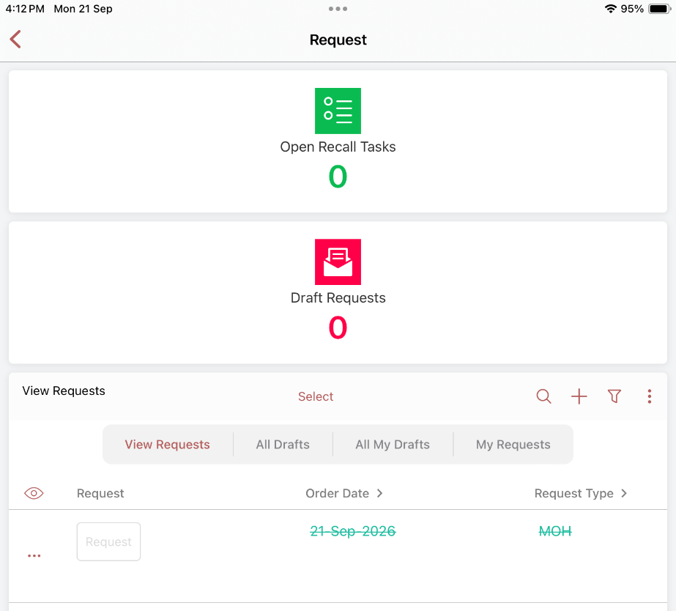
Minimum requirement to save as a Draft is Client Name and 1 item
- Dashboard > Request
- Click Add +
- Enter the Patient’s NHI
- Click in the Client field to display the client or click Add New to create a new record
- Select the Request Type
  - defaults to MOH but can select others. The loan timeframe is derived by the Type
  - if the Request Type is ACC, you will need to record the ACC45 number and Client Discharge Date
- Dates – default to current but can be changed if you wish
- Assessor – defaults to logged-in user. Click to search for another Assessor name if completing this on behalf of the Therapist. Any Recall tasks will go to the Assessor listed in this request.
- Urgency – in the Dispatch dashboard, Urgent will display the record in Red and have a count under Urgent
- Catalogue Items > press Tap to add records
  - Press Add New
  - If you want equipment dispatched from another site, select the appropriate From Warehouse
  - Category > press Tap to select choice
  - Catalogue Item > press Tap to select choice > search by typing any part of the description or model code > tap the item to select
  - Qty at Main Location = your main hospital store
  - Qty at Offsite Location = other sites linked to your hospital
  - Ship To > Tap to select choice to select where you want it sent to
  - Select + to add an additional item or Back (<)
  - Repeat steps 9a-g
- Enter Delivery instructions as required, e.g.
  - record the barcode if it is already issued
  - record Ward name if the Ship To is Client Ward
  - record approximate time if Client/Assessor pick-up
- Press Save as Draft
When a request is saved, it is saved as a draft. This enables you to make any edits before submitting it to become a dispatch record.
The request will show in the dashboard in red as a Draft until it is “requested”.

- To create a Dispatch record, click Request
- Click Yes to confirm Request
Notes:
- A separate dispatch record will be created for:
  - Different Ship To options, e.g. Client Home, Ward
  - 0 amount at Main Location – (Stock Demand dispatch record)
- Once the Request is submitted, it cannot be changed.
You can copy an Order by pressing Select > select the record, and press Copy.
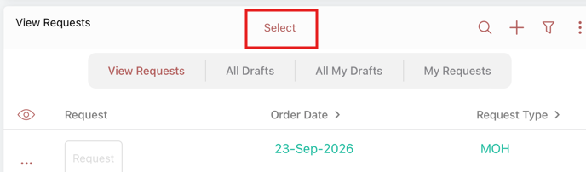

Edit a Draft Request
To edit the request while still in Draft:
- Press the number under the Draft Requests icon
- Tap on the record, then click Edit
- Make any changes required
- To change an item, tap the records
- To Cancel an item – hover to the left of the item and click delete 
- Press Update

Delete a Draft Request
To delete a Request after it has been requested, please refer to the “Cancelling a Dispatch/Request”.
To delete a Draft Request:
- Press Select > select the record, and press Delete Draft

Order Status
Status | Description
Draft | Can be edited by the Assessor  Request has not yet been sent to Store
Requested | A dispatch record is displayed for Store
Partially Dispatched | Some of the items requested have been dispatched by the Store while there are others on Stock Demand
Dispatched | All items requested have been dispatched

Print a Request
- Press Select > select the record, and press Print

Reissue
Search options
– Search Options: you can set your search options by any of the headings in the grid, e.g. to display by Client or Barcode.
Sometimes, you may deliver an item to a client, and they decide they don’t want/need it. If you have another client who needs the same item and the item meets hygiene and safety measures, it can be reissued to another client without going through the inwards goods / create new request process.
Each item in your catalogue is either tagged that it can be reissued or not. Where it can’t, the Reissue button won’t be available.
Please ensure you check the Hire Type as this will decide the loan period, if it can be transferred to DSS or billed to ACC.
- Dashboard > Reissue
- Press the Search button
  - Press the Barcode Gen and type the barcode number in the field under “Contains”, OR
  - Press the QR URL and scan the QR code in the field under “Contains”
  - Press Apply
- Press the Reissue button
- Enter the new patient’s NHI and select the New Client
- Change the Hire Type if required
- Press Submit
This action will:
- Cancel the existing return record and create a new return record for the new Client
- Cancel the existing Recall record and create a new Recall record for the new Client
- Cancel the existing Reissue record and create a new Reissue record for the new Client
- Client History’s will show reissue to and from clients

Dashboard – Dispatch

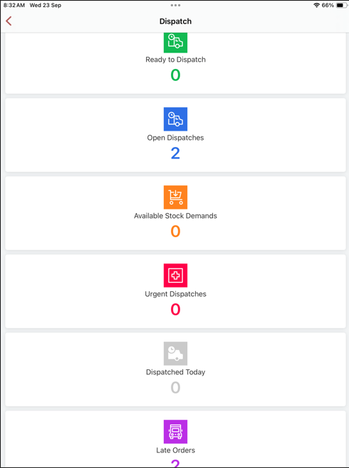

Overview
There are two parts to dispatching Short Term Loan equipment; the first is assigning the actual barcodes to the items requested and the second, marking the record as Dispatched. This second part:
- removes the dispatch record from the dispatch list
- changes the original request Status to Dispatched
- creates a Return record so it can be returned
- creates a Recall/Loan record to manage the recall of the equipment
- creates a Reissue record to allow the Therapist to transfer the item from one patient to another
- updates the Client History as dispatched to that Client
- updates the Inventory count and displays in View Equipment as On Loan
- displays a record in Current Loans > View Loans where a loan document can be printed
The records with a Status of Requested have requested items which are available in your store and are ready to dispatch.
The records with a Status of Stock Demand have requested items which are not available.
The Ship To column will advise you where the Therapist would like the equipment delivered to. The Delivery Instructions will provide further information regarding the request. For example, which pick-up time if “Pickup Client” has been chosen as the Ship To option or the barcode number if the item has already been physically issued.

Dispatch Status
1 | Requested Assign Equipment – Urgent, waiting to have items assigned, displayed in Red
2 | Requested Assign Equipment - waiting to have items assigned, deliver to Assessor
3 | Ready to Dispatch – items assigned, ready to dispatch and create loan record
4 | Stock Demand – item not currently available in your warehouse
5 | Available Stock Demands – when there is a Stock Demand dispatch record and there is now an item available to complete the dispatch

Search options
– Search Options: you can set your search options by any of the headings in the grid, e.g. to display only your dispatch records, search by yourself as the Assessor; to search for a client, search by Ship To Text.

Print a Pick Slip
You can print a pick slip before and after you’ve assigned items to your dispatch record. If after, it will display the barcode numbers you have assigned.
- Scroll down to view the dispatches > press Select
- Press the record > press Print and press Print

Assign Equipment
- Dashboard > Dispatch
- Press Open Dispatches and press the record for dispatching
- Press Edit and press the Line Items
- Press Select Equipment - to select choice
- Scan the QR code in the Scan Barcode field, or
  - Select the barcode of the item being dispatched
- Tap on any additional items and complete steps 4-5
- Press Back (<)
- Press Update
- Press the X in the Dispatch record
Once all items have a barcode assigned, you can mark the record as dispatched. The Dispatch record will go to Ready to Dispatch status and green text.

Mark as Dispatched - singular
- After assigning equipment, press Select
- Select the items to dispatch by pressing the circles against the record
- Press Mark as Dispatched and Yes to confirm

Mark as Dispatched - bulk
- After assigning equipment, press Select
- Press the Select All circle at the top of the list
- Press Mark as Dispatched and Yes to confirm

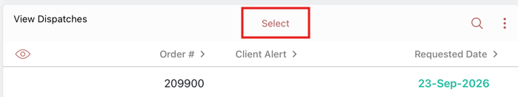
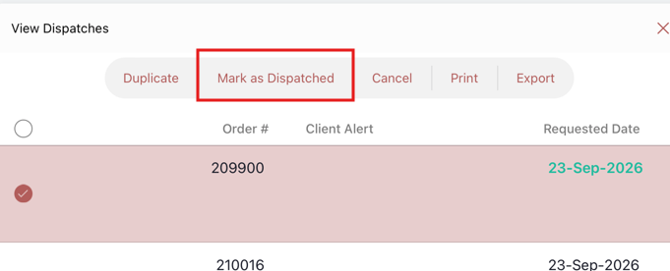
This action will display a record in the:
- Returns view as Equipment on Loan so they can be returned
- Recall view to enable a Recall Request (extension, STL-LTL, etc.) and where a recall document can be printed
- Reissue view
- Client History as dispatched to that Client
- View Inventory and View Equipment as On Loan
- Current Loans > View Loans (where a loan document can be printed)

Printing Loan Document
- Dashboard > Current Loans > View Loans
- Click Search
  - Click Client and enter the NHI or Name in the blank field below “Contains” and click Search
  - Press Select
- Select the record by pressing the circle against the record
- Press Print the press Print

Edit a Dispatch Record
You may be asked to edit a dispatch record for the Therapist if they want to exchange or remove an item or they have forgotten to add an item after they have submitted their Request.
- Dashboard > Dispatch
- Press Open Dispatches and press the record for dispatching
- Press Edit
- Press the line item
To change an existing item:
- Press the Catalogue Item and press the correct item from the list
- Press the Line Items and press Select Equipment Tap to select choice
- Select the barcode of the item being dispatched
- Press the Back > icon
- Press Update
To cancel an existing item:
- Press the Delete icon
- Press the red circle
- Press Delete
- Press Done
- Press the Back > icon
- Press Update
To add an additional item:
- Click Add New. Press the +.
- Select the Catalogue Item and Equipment Barcode number
- Press the Back > icon
- Press Update
  - Select the Catalogue Item from the drop-down list
- Click Update to save the changes.

Cancel Dispatch/Request
This Cancel Request action needs to be treated with a bit of care. This Cancel button not only deletes the Dispatch record, but it deletes the whole related Request.
These are the checks to complete before cancelling the Request and Dispatch record:
- Check with the Therapist to ensure they want the whole request deleted
- If yes, confirm the items and the date requested

- Check the Dispatch screen to see if all the items requested are displayed
  - If all the items don’t display, click the “Dispatched” number
  - Search for the Client
  - If there are dispatch records with the items and the same Requested Date, complete the “Cancel Request Item” task
  - Click the White X to close this screen
- If the Dispatch records do display all the items, they can be cancelled
To cancel the Request and Dispatch record:
- From the Dispatch screen, press the record to cancelPress Select
- Select the items to dispatch by pressing the circles against the record
- Press Cancel
- Press Close
- The Dispatch and Request records will be deleted
- An email will be sent to the initiating Therapist advising them of the cancellation.

Add New Equipment - Scan
When you get new equipment, you can add it to Inventory. Where there is a Stock Demand dispatch record for the newly created item, a pop-up will display to take you to a screen which will enable you to dispatch the Stock Demand.
- Inventory > Add New Equipment
- Scan the first QR code in the Scan Barcode
- From the Catalogue Item, press Select Equipment Tap to select choice
- Enter the Quantity
- From the Warehouse Location, press Select Equipment Tap to select choice
- Press a Warehouse Location and press Submit
If there is a Stock Demand record for this item, an Available Stock Demands screen displays:
- Click Complete Stock Demand
- Select the equipment number from the menu and click Update
The item can then be Marked as Dispatched

Add New Equipment – Manual
- Inventory > Add New Equipment
- Select Manual
- Select the Prefix Code 9401137
- Enter the first QR code in the Barcode – 8 digits
- From the Catalogue Item, press Select Equipment Tap to select choice
- Enter the Quantity
- From the Warehouse Location, press Select Equipment Tap to select choice
- Press a Warehouse Location and press Submit
If there is a Stock Demand record for this item, an Available Stock Demands screen displays as mentioned above.

Edit Equipment
This can be used to change the Model Number if the incorrect item has been recorded incorrectly against the physical item, or the Barcode has been recorded incorrectly.
- Inventory > View Equipment
- Click the Search icon and tick Barcode Gen
  - In the field under ‘Contains’ enter barcode number you are seeking, OR
  - Tick QR URL and scan the QR code
  - Press Apply
- Tap the record and press Edit
- Tap the Model Number to search and select the correct model
- Press Update

View Equipment History
- Inventory > View Equipment
- Press the Search icon and tick Barcode, or
  - Scan the QR code in the QR URL field
  - In the field under ‘Contains’ enter barcode number you are seeking
  - Press Apply

Retire an Item
If you realise the item is no longer fit for purpose or has been lost, it can be retired. Retired items, except for those transferred to LTL, can be restored and added to inventory; e.g. item found.
- Inventory > View Equipment
- Press the Search icon
  - Press the Barcode Gen and type the barcode number in the field under “Contains”, OR
  - Press the QR URL and scan the QR code in the field under “Contains”
  - Press Apply
- Press Select and press the circle against the required record
- Press Retire
- Select a Reason for Retirement – Tap to select choice
- Enter a Reason Note and press Done
- Press Submit
– Search Options: you can set your search options by any of the headings in the grid, e.g. to display by Retired

Return Retired Item
- Inventory > View Equipment
- Press the Search icon
  - Press the Barcode Gen and type the barcode number in the field under “Contains”, or
  - Press the QR URL and scan the QR code in the field under “Contains”
  - Press Apply
- Press Select and press the circle against the required record
- Tap the record and press Edit
- Remove the tick from the Retired box and press Done
- Add a Note, press Done
- Press Update

Returns
The return items function does the following:
- Reissue/Recall/Loan/Return – Removes any records for that item
- Client History – records the return of an item
- Inventory – subtracts 1 from On Loan and adds it to In Quarantine
- View Equipment – changes the Status of the equipment from On Loan to In Quarantine
In a request, the item won’t display in the count as “At Main Location” until it is Moved to an In Stock location.

Returning equipment Dispatched from other sites
There is the ability to return any Short-Term Loan equipment which has been returned to your site. All equipment returned will continue and be put to a status of In Quarantine.
If the item you return from another hospital is also in your catalogue, you will be able to Move them into an available location at your site. If the item is not in your catalogue, you can either request it to be added, or transfer the item to the original dispatching hospital.
There are two ways items can be selected for returning:
- Dashboard > Return
- Ensure the cursor is in the Scan Items box, scan the barcodes of each item/s, OR
  - Type the barcode number and press return on your keyboard to enter any additional items
- Press Return
- Press Select, press the Select All box and press Return Items
- Ensure the number of items returned match the physical items being returned
- Press Close
Or
- Dashboard > Return
- Tick the Items listed in the “Equipment On Loan” section and click Return Items
- Ensure the number of items returned match the physical items being returned
- Click “Got It” to the confirmation message

Move
Items can be moved from one location to another within a warehouse. The most common being moving the item from Quarantine, after cleaning, to an In Stock location where it can be seen as available in a request.
Please note: Only items which have been dispatched from your warehouse are able to be moved from Quarantine. To progress equipment from another site, you will need to Transfer it back to them.
- Dashboard > Move and Transfer
- Ensure the cursor is in the Scan Items box, scan the barcodes of each item/s, Or
  - Type the barcode number and press return on your keyboard to enter any additional items
- Press the Move/Transfer button and press Select
- Press the Select All box and press the Move button which displays
If you want to move all the equipment to the same location:
- Select the Location from the Bulk Destination Location menu and press Set All. This will apply the location entered in the Bulk Destination Location to the New Location fields for all equipment listed
If you want to move multiple equipment to multiple locations:
- Select the Location from the New Location field for each equipment item listed
- Press Submit
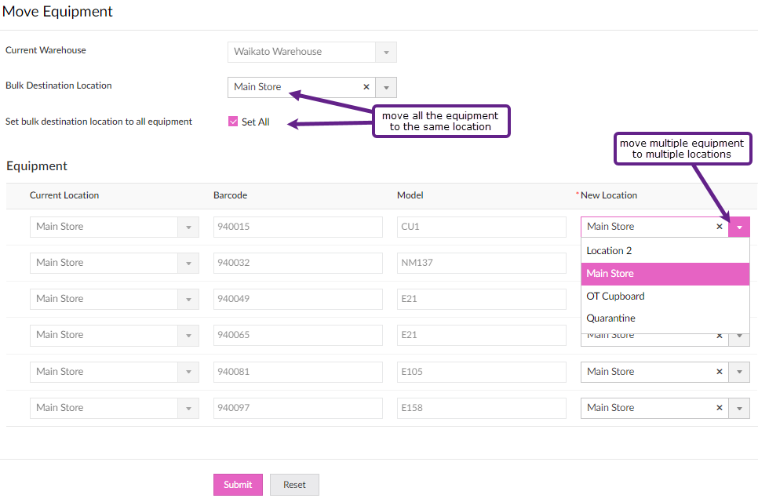

Transfer
There is the ability to record the transfer of items between hospitals with the STL system. Equipment can only be transferred to another hospital; it cannot be taken by another hospital. When you transfer the equipment, it will display in the selected hospital’s Quarantine location, and the equipment status will be In Transit.
- Dashboard > Move/Transfer
- Ensure the cursor is in the Scan Items box, scan the barcodes of each item/s, Or
  - Type the barcode number and press return on your keyboard to enter any additional items
- Press the Move/Transfer button and press Select
- Press the Select All box and click the Transfer button which displays
- Select the new Warehouse from Tap to select choice and press Submit

Recalls
– Search Options: you can set your search options by any of the headings in the grid, e.g. to display by Client, Items Due Back date and/or Assessor.

Recall Overview
Because the request to Recall may come from a Storeperson or an Assessor, there are two actions to complete a Recall:
- Recall Request
- Action Recall

Recall Tasks
Action selected | System action
Contact Patient Successful/Unsuccessful  Follow-up | A Recall note will be added to the Recall record  Creates a recall note and enables searching by follow-up
Extension, STL-LTL or Contact Patient | A task will go to the Assessor assigned to the Recall record for them to action.  These are displayed in the Request Dashboard – Open Recall Tasks
Collection | Creates a Collection record

Recall Action – (incl. STL-LTL replenishment)
Action selected | System action
Extension – Change the Recall Extension Date, add a Note (optional) and Submit | The Recall record’s Item Due Back Date will change to the new date entered and any note will be displayed.  The Open Recall Task is removed
STL-LTL – ensure the Request Type = MOH, enter eligibility details and Submit | The Recall record is removed  The items are retired with a status of Transferred to LTL.  This item cannot be returned to STL using the same barcode.  The Equipment History will display it has been transferred to LTL  The details are sent to Enable NZ to request a LTL replenishment item  The Open Recall Task is removed  The STL-LTL details can be viewed via Inventory > View STL-LTL Transfers
Contact Patient – add a Note and Submit | A Recall note will be added to the Recall record

Recall Tasks
If you are not the initiating Therapist but you have approval to extend the Recall date, please refer to the Edit a Recall Record.
To request an Extension, STL to LTL replenishment or Contact Patient against the Recall record:
- Dashboard > Recalls
- Press the Recall button against the relevant record
  - For STL to LTL requests, please ensure the Request Type for the patient is MOH.
  - Only items ticked “Transfer Allowed” can be transferred from Short to Long Term
- Press the relevant Recall Action radio button and enter a note in the Notes field,
- Press Submit.
Note:
Extension – if there are multiple items listed and you want to extend only some, hover to the left of the item and click to remove the item from the Extension request. It does not remove the item from the Recall record.
Collection - if there are multiple items listed and you want to collect only some, hover to the left of the item and click to remove the item from the Collection request. It does not remove the item from the Recall record.
STL-LTL – When choosing STL-LTL, and there are items not ticked as “Transferred Allowed”, hover to the left of the item and click to remove the item. It does not remove the item from the Recall record.
STL-LTL – When choosing STL-LTL, only Request Type of MOH can be transferred to DSS.
.
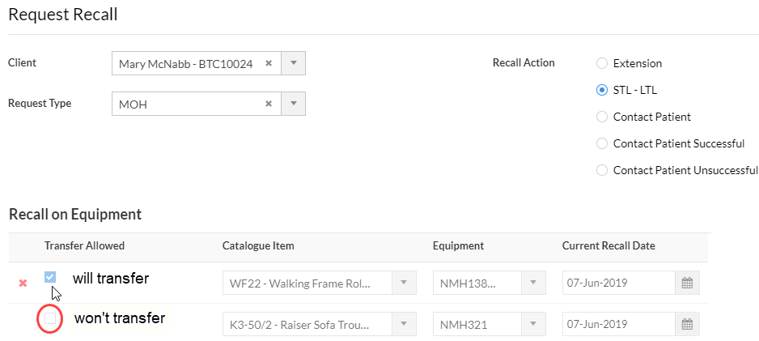

Recall Action – (incl. STL-LTL replenishment)
- Dashboard > Request > press the number under “Open Recall Tasks”
- Click Action on the record
- Press the Equipment List records added to view the items
- Select the Recall Action you wish to complete:
Recall Action | Tasks
To remove any items from the list of items | Press the Delete  icon from the open item
Extension | Enter Recall Extension Date and add a Note
STL-LTL | Ensure the Hire Request Type = MOH  To remove any items from being transferred to LT, press the Delete icon  Enter Eligibility details
Contact Patient | Enter a Note
- Press Submit

Reassign Recall records
Reassigning Recall records is to enable transferring caseloads from one Therapist to another.
- Reassigning is completed via the Recall screen.
- Press the Search icon
  - Select Assessor and enter the original Therapist’s name in the text field under the “Contains” drop down menu
  - Press Apply
- Tap the record and press Edit
- From the drop-down menu in the text box, select “Assessor”
- Tap the Assessor field, search/select the name of the Therapist to reassign the record to
- Press Update
- The selected Recall records will now have the new Therapist name displayed

Edit a Recall Record
- Dashboard > Recall
- Search and locate the required Recall record
  - Press the Search icon
  - Press Client
  - Enter the patient NHI in the field under the word “Contains”
  - Press Apply
- Tap the record and press Edit
- To edit the Request Type
  - Select the option from the menu > and click Okay to the warning

- To extend the Recall date, press the Loan Items records
  - Tap to select the item
  - Tap to select the new date from the Date Due Back and press Done

- To add a Recall Note, under Recall Notes press Tap to add records
  - Press Add New
  - Select the Recall Note Type
  - Record your note
  - Press Back <
- Once you have made changes, press Update

Print Recall Letters
- Dashboard > Recall
- Press Search to search for any recall record using these headings.
  - For example, click Next Date Due Back
  - Press “Is ” and select the timeframe to search, e.g. Current or Next Week
  - Press Apply
- Press Select and press the circles against the required records
- Press Print > Print
- For one Client, press the client name, press the More Info Print and Print

Merge Recall Records
Separate Recall records happen when the Request has a mix of available and Stock Demand items. This type of Request creates two separate Dispatch records and therefore two separate Recall records once they are all dispatched.
Another example may be where the Occupational Therapist has done a request for a patient and a Physiotherapist has completed a separate request for the same patient within a similar timeframe.
Note: Once Merged they cannot be undone.
The Merge option is in the Recall screen.
- Dashboard > Recalls
- Press Search
  - Press Client and enter the NHI or Name in the blank field below “Contains”
  - Press Apply
- Check the Client Name, NHI and Type are the same for each record
- Check to ensure the Next Dates Due are within a similar timeframe
- After assigning equipment, press Select
- Select the records to merge by pressing the circles against the record
- Tick the records to merge and click the Merge button which will display
- Press one of the names from the “Select Loan to Merge Into”
- Double-check the Name details
- Press Submit

Collections
When a Collection task is created, the user is taken directly to the Collections screen.

Edit a Collection
- Reports > Collections
- Click the Search 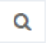 icon and tick Full Name or Equipment to Collect
  - In the field under ‘Contains’ enter part of the patient’s name or the barcode of the item
  - Press the Enter key twice
- Hover to the left of the record and click the blue dots and Edit
- Update the required fields and click Update

Generating an ACC4249
For hospitals who claim from ACC post-6-week issue of STL equipment
- Dashboard > Recall
- Press the Search icon
  - Search for your patient, or
    - Press Type and enter ACC in the text box under “Contains”
  - Tick the Next Date Due Back
  - Select your date range option from the “Is” menu and press Apply
  - Press Select and press the circles against the required records
- Press the Process ACC4249 button which displays
From the ACC4249 Reports screen:
- Tap the record and press Edit
- Update the 4249 Status to Printed
- Enter the Sent to ACC date
- Enter the Clients Acute Discharge Date
- Complete the Equipment Details fields for each item
- Press Back <
- Press the More Info icon and press Print/PDF

Editing an ACC4249
Using the 4249 Status, Followed up with ACC and Notes section can assist you to track where in the process the ACC4249 is at.
Text recorded in the Comments section will display on the ACC4249 form.

STL-LTL Records
There is a screen which you can use to identify items which have been requested to be transferred to long-term and which items you have received a replenishment item for.
- From the Inventory menu > View STL to LTL Transfers
  - When a STL-LTL request is completed by the Therapist, a record is created here and displayed in red text
- When the replenishment item is received search for the client named on the packing slip
  - Press Search
  - Press the Client box and enter their NHI in the text field under “Contains”
  - Press Apply
  - Press Select and press the circles against the required records
- Press the Mark as Completed button which displays
This action will remove the record from the list, indicating you have received the replenishment item.
To view replenished STL-LTL records, go to Inventory menu > Closed STL to LTL Transfers.

Clients
As well as adding new clients from within a request, this can also be done separate to a request.
View Clients is where you view their contact details and edit if required. It also provides a link to the client’s equipment history.
View Client History is a direct view of client’s equipment history.

Add New Client
- Clients > Add a Client
- Enter Name and Email (if provided)
- Enter NHI and Client DoB
- Select Gender and Client Ethnicity
- Record Client Alert if required (this info will display in Request, Dispatch, Recall and Collection records)
- Press Tap to add records and Add New to record the client’s address (the delivery address will default to this address)
- Press Tap to add records and Add New to record to record the client’s phone (the Default Phone Number will default to this)
- Click Submit
Having the Client’s address and phone details is vital for being able to Recall the equipment.

View/Edit Client Record
- Clients > View Clients
- Enter the client’s NHI and press Search
- Press View Clients to see the results
- Tap the record and press Edit
- Edit changes as required and press Update

View Client History
- Clients > View Client History
- Enter the client’s NHI and press Search
- Click View Clients to see the results

Stock-Take
When you want to do a stock-take you can set a filter on the items to check and export the items listed into a spreadsheet.
- To obtain a list for stock-taking, go to the View Equipment screen.
- Press the Search icon
  - Press the Status box and select In Stock from the menu
  - Click outside the menu box
  - Using the other headings listed, select your options
  - If you want to stock-take a specific item, tick the Model Number box and enter the model in the text field under the “Contains” menu
- When you have completed your search options, press Apply.
- Press the More Options icon, then Export, > Export As and press CSV
- Press Export
- Press Upload and select your option
If you have found items which are not on your “In Stock” list or are missing items, search for them via the View Equipment screen:
- If the found item has a Status of “On Loan”, complete the Return and Move tasks to record them in your Store

- If the found item has a Status of “Retired”, refer to Return Retired Item

- If the found item has a Status of “Transferred to LTL”, please return it to your closest Enable NZ Warehouse as this is now a DSS item

- If you have identified items missing from your “In Stock” list, refer to Retire an Item

These actions will update the Inventory counts.

