WATCh-Ad Assessment Form
(Wheelchair Outcomes Assessment Tool for Adults)
Adapted with permission
https://www.bangor.ac.uk/cheme/watch-the-wheelchair-outcomes-assessment-tools

Information for wheelchair users and carers
We are using this form as part of your assessment, to help us to find out what goals you have in relation to your new wheelchair. The form has two parts:
- Part A lists some areas of your life which your wheelchair might be able to help you with. Please decide which are the FIVE most important areas to you
- Part B then asks you to score how satisfied or happy you are now with each of the top FIVE areas you chose in Part A
Once you’ve had your new wheelchair for a few months, we will ask you to score your top five list again to see if there has been any improvements. If you have any questions about the form, or problems filling it in, please let the person doing your assessment know. See below for an example of how to complete this form.

Example of how to complete Part A:
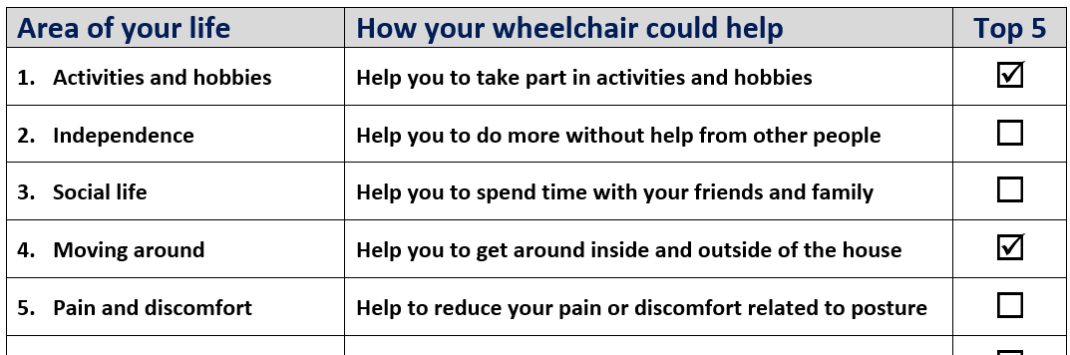
Tick your top FIVE areas

Example of how to complete Part B:
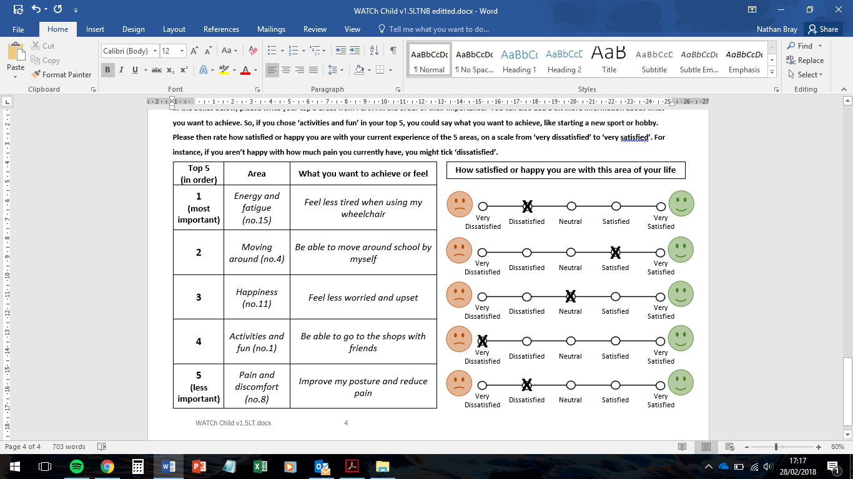
Transfer answers
from Part A

Privacy statement: This form collects personal information about the named individual for the purpose of assessing and supporting the provision of a wheelchair. The information may be provided by the individual, a parent/carer, or an assessor and shared with Enable New Zealand for assessment, funding, equipment provision, delivery, and related oversight. If you are completing this form on behalf of the individual, please ensure the individual has been informed that their information is being provided to Enable New Zealand for these purposes. Information will be held securely and managed in accordance with New Zealand Privacy laws. For more information about how Enable New Zealand manages personal and health information, including access and correction rights, please see Enable New Zealand’s Privacy Statement on our website or contact us. https://enable.co.nz/privacy

Patient name: Date of birth: NHI number:
Assessor name: Date completed:
Completed by: Patient Parent/carer Assessor

PART A
Area of your life | How your wheelchair could help | Top 5
- Activities and hobbies | Help you to take part in activities and hobbies
- Independence | Help you to do more without help from other people
- Social life | Help you to spend time with your friends and family
- Moving around | Help you to get around inside and outside of the house
- Pain and discomfort | Help to reduce your pain or discomfort related to posture
- Self-care | Help you to wash and dress yourself
- Feeling included | Help you to feel part of wider society
- Managing your condition | Help to manage your condition and avoid health problems
- Communication | Help you to communicate and interact with others
- Work and education | Help you to access work and/or education
- Happiness | Help you to feel happy and free from worry
- Safety | Help you to feel safe and secure
- Carer wellbeing | Help your carer to stay happy and healthy
- Self-esteem and confidence | Help you to feel more self-confident
- Energy and fatigue | Help you to feel more energetic and less tired
- Achievement and goals | Help you to achieve the things that are important to you
- Anything else?
Please tell us here:
Below is a list of different areas of your life which your new wheelchair could make a difference to. Please look at this list and place a tick in the box next to the top 5 most important areas for you.
Please make sure you only chose FIVE areas. If there’s something missing from the list, you can write it in the space at the bottom.

Patient name: Date of birth: NHI number:
Assessor name: Date completed:
Completed by: Patient Parent/carer Assessor

PART B
In the boxes below, please write your top 5 areas from Part A in the order of their importance. You can also add a bit more information about what you want to achieve. So, if you chose ‘activities and hobbies’ in your top 5, you could say what you want to achieve, like starting a new sport.
Please then rate how satisfied or happy you are now with your experience of the 5 areas, on a scale from ‘very dissatisfied’ to ‘very satisfied’. For instance, if you aren’t happy with how much pain you have at the moment, you might tick ‘dissatisfied’.
Top 5  (in order) | Area | What you want to achieve or feel | How satisfied or happy you are with this area of your life
1  (most important) |  |  |  | Very dissatisfied | Dissatisfied | Neutral | Satisfied | Very Satisfied | 
2 |  |  |  | Very dissatisfied | Dissatisfied | Neutral | Satisfied | Very Satisfied
3 | . |  |  | Very dissatisfied | Dissatisfied | Neutral | Satisfied | Very Satisfied
4 |  |  |  | Very dissatisfied | Dissatisfied | Neutral | Satisfied | Very Satisfied
5 |  |  |  | Very dissatisfied | Dissatisfied | Neutral | Satisfied | Very Satisfied

